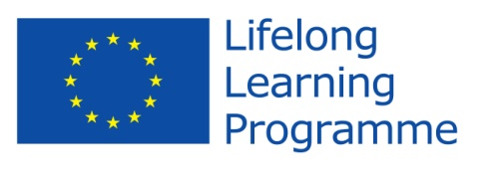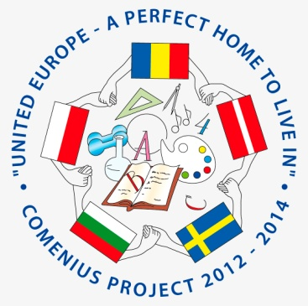

Comenius Project
United Europe - a perfect home to live in.

Final Questionnaire for students

- What is your first thought when you hear “United Europe - a perfect home to live in”?
I liked everything, it was nice to welcome guests to us and it was interesting to communicate with them through various forms of social sites, I really liked this project
Life in Europe
We are European countries with good relations, harmony, friendship, which we could feel during the project.
In Europe we can pay with the same currency and can travel to other countries and avoid paying for customs.
Project at school
Interesting project
Beautiful places to live and which to visit
Transnational friendship.
I immediately I had an idea, that we will find places that are not in Latvia, but that is as nice to live in that home.
New friends

- Do you think that your participation in the project have you improved your foreign language skills?
  - Yes 95%
  - No 5%
- Do you think the project was valuable in helping to improve attitudes towards people from different countries?
  - Yes 100%
  - No
- Are you proud of being a member of the team?
  - Yes 100%
  - No
- Can you name the countries and the towns involved in the project with you?
Bulgaria - Sliven, Poland - Kronowo, Romania - Hunedoara, Sweden - Kinna
- Which activities do you like during the Project? (underline)
- Make a presentation about the school / the country
- Make posters about partners’ countries and traditions
- Draw a logo
- Take photos
- Share recipes and cook
- Make e-vocabulary
- Research Easter tradition and make posters
- Exchange e-mail
- Collect data for CD – Top hit
- Write articles
- Make and send greeting cards
- Take part in teleconferences
- Make movie about school festivities and school activities
- Make posters about the first project year
- Celebrate Valentine’s day
- Take part in recycling session
- Write articles with impressions and reflections
- Organize Comenius Gala day
- Host friends
- Be a guest!

- How many words do you know in these languages? (don’t fill native)
Romanian -6
Swedish -7
Polish -6
Bulgarian - 7
Latvian -......................................................................................................
- Which singers and groups do you know in partner countries?
Romania -.......Maxim, Inna, Paula Selinga
Sweden -.......Avicii, Loreen, Swedish House Mafia, Eric Saade
Poland -..........Marcins Mrozinskis Ewelina Lisowska, Doda
Bulgaria -.....Joker Flow......................
Latvia -.......................................................................................................
- Do you know how to find our project in Facebook?
  - Yes 95%
  - No 5%
- What is the website address?
...... http://eucomenius.ucoz.com/ ...............
- How much do you have in common with the partner countries’ students?
- Not at all
- A little bit 5%
- So...so 30%
- Much 35%
- Very much25%
- What do you like the best during these two years?
Visit and travel
Meet new students from other countries
Get to know other countries and their culture
Almost everything
- Would you like to participate in new projects?
  - Yes 100%
  - No
Thank you!

