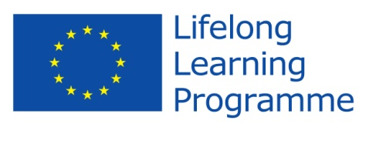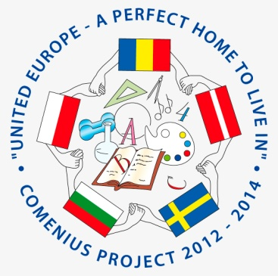

Comenius Project
United Europe - a perfect home to live in.

Final Questionnaire for students

- What is your first thought when you hear “United Europe - a perfect home to live in”?
all nations are united
We can communicate due to English language.
- Do you think that your participation in the project have you improved your foreign language skills?
  - Yes
  - No
- Do you think the project was valuable in helping to improve attitudes towards people from different countries?
  - Yes
  - No
- Are you proud of being a member of the team?
  - Yes
  - No
- Can you name the countries and the towns involved in the project with you?
Bulgaria-Sliven , Latvia- Ryga ,Sweden-Kinna,
Hunedoara- Romania

- Which activities do you like during the Project? (underline)
- Make a presentation about the school / the country
- Make posters about partners’ countries and traditions
- Draw a logo
- Take photos
- Share recipes and cook
- Make e-vocabulary
- Research Easter tradition and make posters
- Exchange e-mail
- Collect data for CD – Top hit
- Write articles
- Make and send greeting cards
- Take part in teleconferences
- Make movie about school festivities and school activities
- Make posters about the first project year
- Celebrate Valentine’s day
- Take part in recycling session
- Write articles with impressions and reflections
- Organize Comenius Gala day
- Host friends
- Be a guest!

- How many words do you know in these languages? (don’t fill native)
Romanian - 6
Swedish -6
Polish -.......................................................................................................
Bulgarian -6
. Latvian -6
- Do you know how to find our project in Facebook?
  - Yes
  - No
- What is the website address?
eucomenius.ucoz.com......................................................
- How much do you have in common with the partner countries’ students?
- Not at all
- A little bit
- So...so
- Much
- Very much
- What do you like the best during these two years?
Travelling abroad, teleconferences , meeting new people and their culture, festival e-cards exchange, talking on facebook, making friendships
- Would you like to participate in new projects?
  - Yes
  - No

Thank you!

