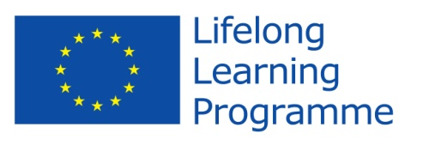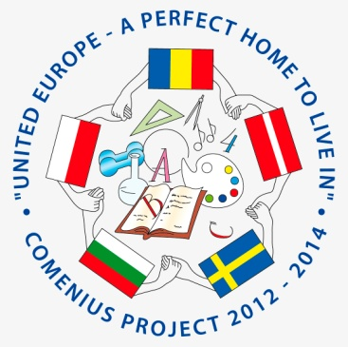

Comenius Project
United Europe - a perfect home to live in.

Final Questionnaire for students

- What is your first thought when you hear “United Europe - a perfect home to live in”?
A good place to be in
Our project
Life in Europe
Friendship
Beautiful places to live and to visit

All our countries are” united”
- Do you think that your participation in the project have you improved your foreign language skills?
  - Yes 100%
  - No
- Do you think the project was valuable in helping to improve attitudes towards people from different countries?
  - Yes 100%
  - No
- Are you proud of being a member of the team?
  - Yes 100%
  - No
- Can you name the countries and the towns involved in the project with you?
Sweden-Kinna
Bulgaria-Sliven
Latvia-Cere
Poland-Kronovo
- Which activities do you like during the Project? (underline)
- Make a presentation about the school / the country
- Make posters about partners’ countries and traditions
- Draw a logo
- Take photos
- Share recipes and cook
- Make e-vocabulary
- Research Easter tradition and make posters
- Exchange e-mail
- Collect data for CD – Top hit
- Write articles
- Make and send greeting cards
- Take part in teleconferences
- Make movie about school festivities and school activities
- Make posters about the first project year
- Celebrate Valentine’s day
- Take part in recycling session
- Write articles with impressions and reflections
- Organize Comenius Gala day
- Host friends
- Be a guest!

- How many words do you know in these languages? (don’t fill native)
Swedish -6
Polish -7
Bulgarian -7
Latvian 6
- Which singers and groups do you know in partner countries?
Sweden Kapten Rod, Magnus Uggle, ABBA, Medina, Swedish House
Mafia
Poland Enej Skrzydlate, Ewelina Lisovska, Weekend, Honorata Razum
Bulgaria Joker Flow
Latvia Gacho, Renars Kaupers, Katy Tindumark, Balle Balozos
- Do you know how to find our project in Facebook?
  - Yes 100%
  - No
- What is the website address?
eucomenius.ucoz.com
- How much do you have in common with the partner countries’ students?
- Not at all
- A little bit 5%
- So...so 10%
- Much 55%
- Very much 30%
- What do you like the best during these two years?
Be a guest!
Take part in teleconferences
Travel
Draw a logo
Take photos
Share recipes and cook
Make e-vocabulary
Make a presentation about the school / the country
Make and send greeting cards
Host friends
Take part in teleconferences
Celebrate Valentine’s day
Take part in recycling session
Write reflections
- Would you like to participate in new projects?
  - Yes 100%
  - N0
  - Thank you!

