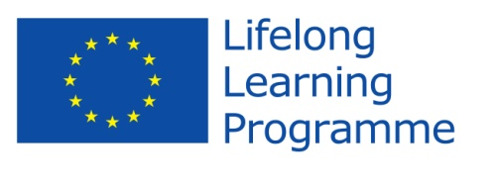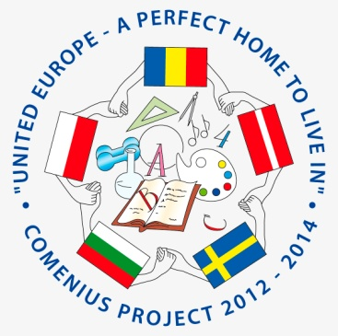

Comenius Project
United Europe - a perfect home to live in.

Final Questionnaire for students

- What is your first thought when you hear “United Europe - a perfect home to live in”?
It is nice to live there
A perfect place
A nice name
A good place to be in
Our project
......................................................................................................................
- Do you think that your participation in the project have you improved your foreign language skills?
No- 30%
Yes- 70 %
- Do you think the project was valuable in helping to improve attitudes towards people from different countries?
  - Yes-80%
  - No- 20%
- Are you proud of being a member of the team?
  - No -10%
  - Yes-90%
- Can you name the countries and the towns involved in the project with you?
About 50 % could name the towns in all countries

- Which activities do you like during the Project? (underline)

- Make posters about partners’ countries and traditions

- Take photos
- Share recipes and cook
- Exchange e-mail

- Write articles

- Take part in recycling session

- Host friends
- Be a guest!

- How many words do you know in these languages? (don’t fill native)
Between 5-10 words for each language (some bad)
- Do you know how to find our project in Facebook?
100 % yes
- What is the website address?
100 % does not know
...............................................................................................................
- How much do you have in common with the partner countries’ students?
75% A lot
25 % a little
- What do you like the best during these two years?
It was fun to meet students from different countries and see how they have it and see that it is such a big difference between the countries and see that we have a really good school and live really good and also travel to the other countries and learn a little about their normal life in their country.
The trips!
Meeting new friends!
- Would you like to participate in new projects?
  - No 25%
  - Yes 75%

Thank you!

