EASTER

On easter we eat:
Janssons frestelse
Lamb meat
Egg
Salmon
And many other things...

Easter traditions in Sweden

In this little book you can read about easter traditions.
Such as the easter bunny, eastereggs, easter witches and easter food.
The book is written of the swedish pupils in the programme.

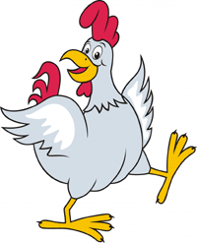

Easter traditions

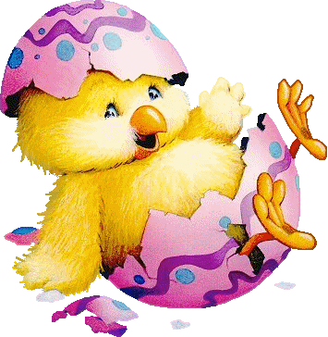

Originally, it is a tradition from Germany and is known from the 1600-late part. The tradition was 150 years relatively unknown in the rest of Germany, but was introduced on a broad scale after 1850 of candy and toy industries, as an Easter symbol to children. About that time, Germany began celebrate Easter, whose motives often consisted of the Easter Bunny.
The Estern bunnie are hiding eastern candyeggs for the children.

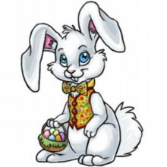

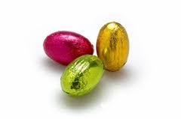
This is some eastereggs that you can buy in a store. This contents and chocolate or floating chocolate inside.

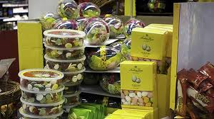

This is also a chocolate but this one you give away under the easter when you go away to see someone.

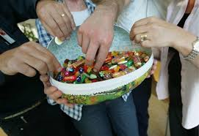
In Sweden you buy some one cardboardegg and give away. The egg fills with lots of different candy. Most of them look like small eggs.

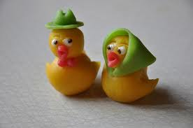
You buy small marzipan chickens which you put on cakes and pastries.

