Easter traditions in Latvia
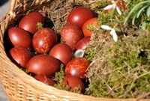
On Easter morning people arose before the rising of the sun, and to obtain health and beauty, they hurried to wash their faces in a spring or a stream running east.
This was followed by one of the most important Easter activities - awaiting the sunrise exactly when it appears in the equinox morning.
Those who had risen first, woke those who were still sleeping and switched them with steamed birch branches. In this way a special force that encouraged fertility and endowed people with health and success was transferred from the branches. This ritual is connected with archaic concepts about the staff of life and its fertility enhancing power.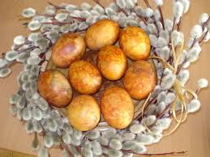
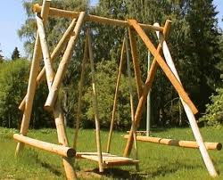
But the Latvian preserves a certain independence from this haste: for instance, one of the most important Easter rituals is hanging of the swing and swinging. But when swinging at Easter, one must not stop the swing; it must stop on its own. Only if the swinging is gentle, will the flax field finish its blooming without being beaten down by rain or wind. According to archaic beliefs, swinging is connected with fertility, and it must be done, so the livestock will do well, as well as the flax, and one will be spared bites from mosquitoes and gadflies.
The first to be swung were usually the master and mistress, after that the rest took their turns. In return for swinging them, the girls paid the boys eggs, pies, or even handmade mittens and socks.
Eggs are given for swinging, and eggs are knocked together to see which one survives cracking, as according to belief, the one whose egg shell was strongest, will live longer.
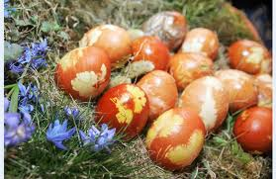
During Easter eggs are rolled and eaten in great quantities, because in addition to round flatbreads and sprouted grains, they are the primary Easter foods.
In the past, eggs for different peoples were a symbol of life, and also in Latvian spring equinox traditions they were given a special place.
Awaiting Easter, eggs were coloured with onion skins, rye shoots, camomile or hay cuttings. This is not such an old custom, but in our day very popular.

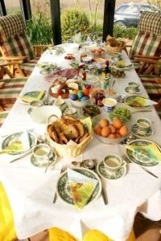
Easter Table
The first thing you must do at Easter is eat eggs as eggs symbolize life and health and if you eat a lot of them you will also stay healthy.
Other foods which you put on your table should have the round form of the sun. Therefore salads are placed in round bowls and little cakes are made round and so on.
Foods should be in all sorts of different colours and that’s why at the Easter table you will see a lot of green, red, orange and yellow.
Among all the sweet threats like special Easter cookies and cakes were also oven baked potatoes, roasts especially pork roast and ribs and different types of salads and vegetables because at Easter it is traditional to fill up tables with all sorts of good things to eat.

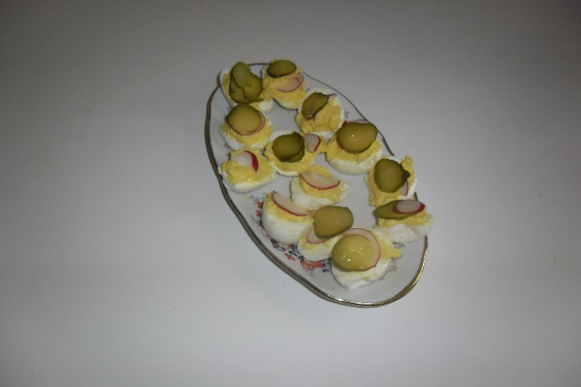
Stuffed eggs
Ingredients:
- 6 boiled eggs
- 50 g cheese
- 3 spoons mayonnaise
- Salt and pepper to taste
- radishes or cucumbers for garnish
Directions:
- Place eggs in a pot of salted water. Bring the water to a boil, and let eggs cook in boiling water until they are hard boiled, approximately 10 to 15 minutes. Drain eggs, and let cool.
- Peel eggs, cut in half, lengthwise,remove the egg yolks and mash them together in a small mixing bowl.
- Cheese grate, mix with egg yolk and mayonnaise.
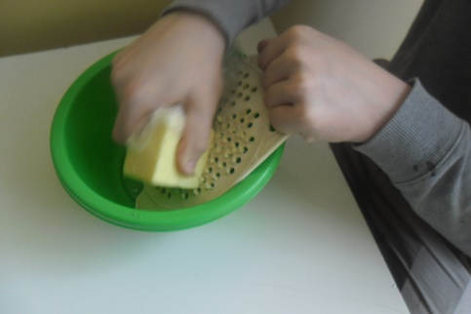
- Spoon mixture into the egg whites; garnish with radish or cucumber.
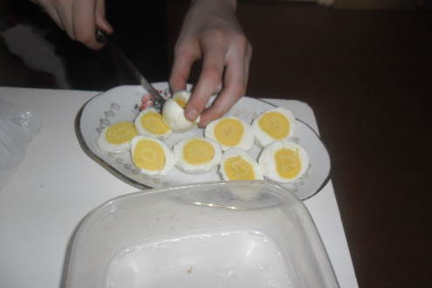
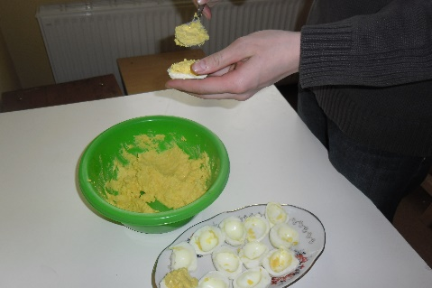
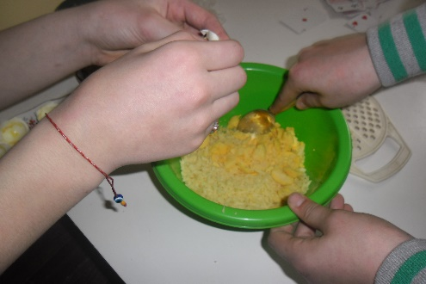
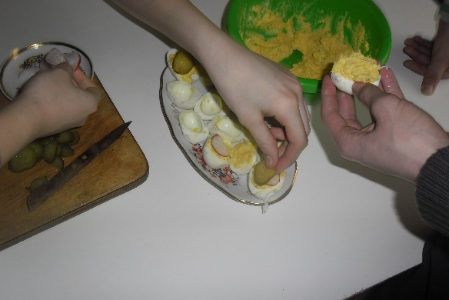
Easter cake
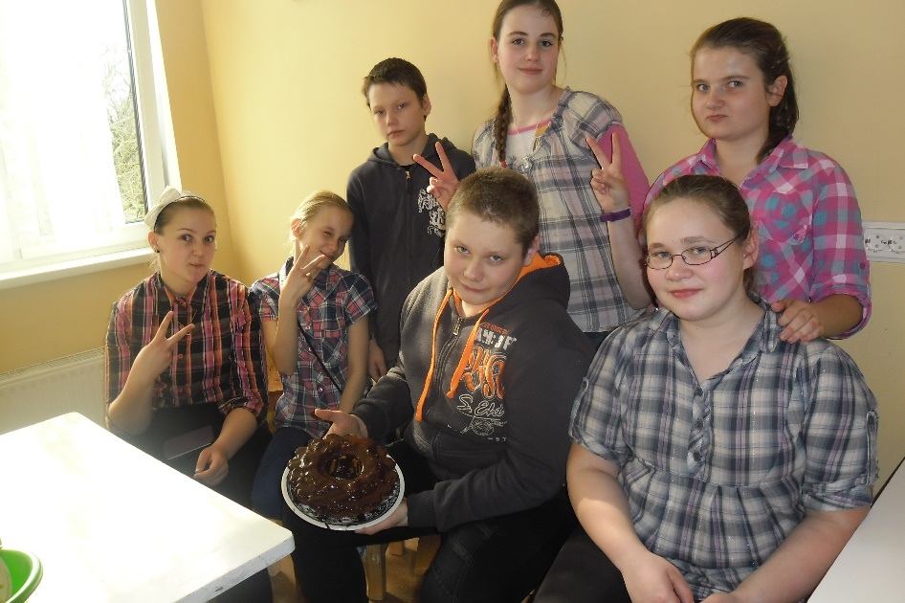
Ingredients:
250 g flour
1 teaspoon baking powder,
4 eggs,
200-250 g caster sugar,
1 teaspoon vanilla sugar
1 lemon,
250 g butter,
Some butter for baking form
Directions:
Flour sieve, mix with baking powder.
Mix butter in homogeneous mass, add eggs yolks one by one, caster sugar, vanilla sugar and lemon juice. You can also add a grated lemon zest.
The mass mix with flour and hard foam whipped egg whites.
Smear a baking form with butter and put the mass in it.
Bake in hot oven 180 degrees about 1 hour.
After baking pour the cake with melted chocolate.
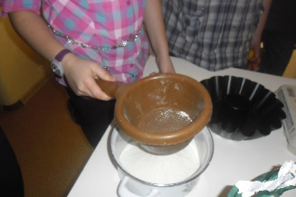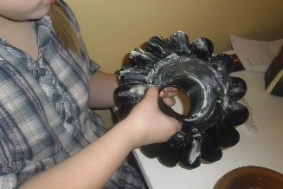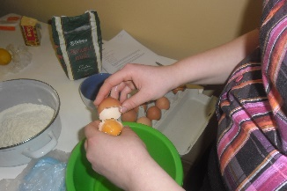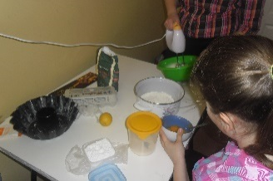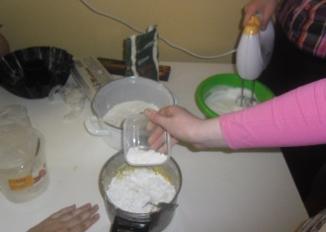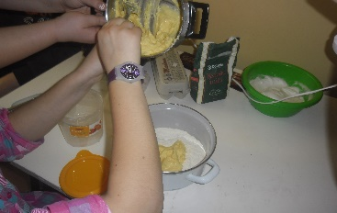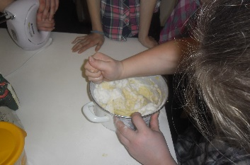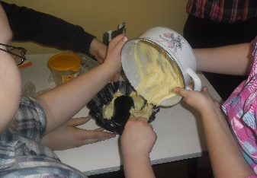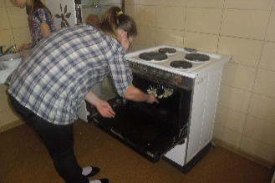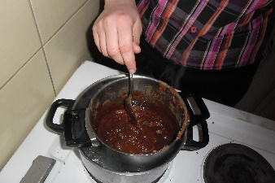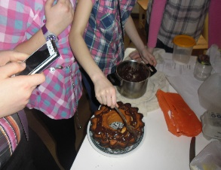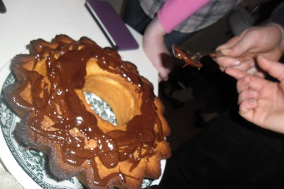
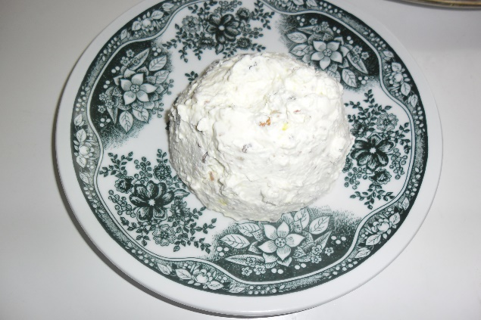
Easter Pasha
Ingredients:
- 1 kg cottage cheese
- 4 eggs
- 100 g butter
- 1 glass of cream
- 170 g sugar
- 150 g hazelnuts
- 100 g raisins
- vanilla sugar
- mold - clay or plastic flower pot with a hole in the bottom.
- cheesecloth
Directions:
Mash cottage cheese to a creamy consistency.
Mix the soft butter with sugar, eggs and a little vanilla sugar.
Mix all with cottage cheese.
Add the raisins and the crushed hazelnuts.
Mix sweet cream. Mix all together.
Line mold with a cheesecloth.
Pour mixture into prepared mold.
Cover with cheesecloth and place a saucer top, with weight on it, so the juice can drain out.
Chill in the fridge at least 24 hours.
