**Traditional Easter Babka Recipe - Polish Babka Wielkanocna**

This Polish Easter [babka](http://easteuropeanfood.about.com/od/ah/g/babka.htm) celebrates the return of the egg to the diet after the strictures of the Lenten fast. A mere 15 egg yolks are featured in this traditional recipe! For a lower-cholesterol, one-rise recipe, try [Easy Babka](http://easteuropeanfood.about.com/od/breads/r/easybabka.htm).   
  
Babka is an indispensable component of a Polish Easter feast and is featured in other cuisines, including Ukrainian where it takes a tall shape similar to a [Russian Kulich](http://easteuropeanfood.about.com/od/russianbreads/r/Russianeaster.htm). More [Eastern European Babka Recipes](http://easteuropeanfood.about.com/od/crossculturaldesserts/tp/Eastern-European-Babka-Recipes.htm).   
  
Prep Time: 20 minutes

### Cook Time: 50 minutes

### 3 (1-hour) rises: 3 hours

### Total Time: 4 hours, 10 minutes

### Yield: 1 (12-inch) Polish Easter Babka

### Ingredients:

* 1 cup milk
* 3 1/3 cups all-purpose flour
* 2 packages active dry yeast
* 1/4 cup lukewarm water
* 2/3 cup sugar
* 2 teaspoons salt
* 15 large egg yolks
* 1 teaspoon vanilla
* 1/4 teaspoon almond extract (optional)
* 1/2 cup melted butter
* 3/4 cup candied citrus rind (optional)
* 1/2 cup chopped almonds (optional)
* 1/3 cup light or dark raisins

### Preparation:

1. [Scald](http://easteuropeanfood.about.com/od/qz/g/scald.htm) milk and pour into a large bowl or stand mixer bowl fitted with the paddle attachment. Add 3/4 cup of the flour, mixing well. Cool.
2. Dissolve yeast in lukewarm water 5 minutes. Add 1 tablespoon of the sugar and let stand 5 minutes. Add to cooled milk mixture, combining well. Cover and let rise until doubled.
3. In a separate large bowl, combine salt and egg yolks and beat until thick and lemon-colored, about 5 minutes. Add remaining sugar and extracts, mixing well. Combine egg mixture with risen milk mixture, beating thoroughly.
4. Add remaining flour and, using a wooden spoon, beat vigorously for 10 minutes or 7 minutes by machine with the paddle attachment. Add butter and continue to beat an additional 7-10 minutes. Beat in candied rind, almonds and raisins. Dough will be sticky. Scrape down sides, cover with greased plastic wrap and let rise until doubled in the same bowl. Punch down dough and let rise again until doubled.
5. Generously coat a 12-inch fluted babka pan or tube pan, or turk's head mold (turban mold) with cooking spray. Punch down dough and, using slightly dampened hands, transfer to prepared pan. Cover and let rise 1 hour or until dough fills the pan. Heat oven to 350 degrees.
6. Bake about 50 minutes or until instant-read thermometer registers 190 degrees or toothpick comes out clean. Cool in pan 10 minutes and invert onto rack to cool completely. Leave plain or dust with confectioners' sugar, if desired.

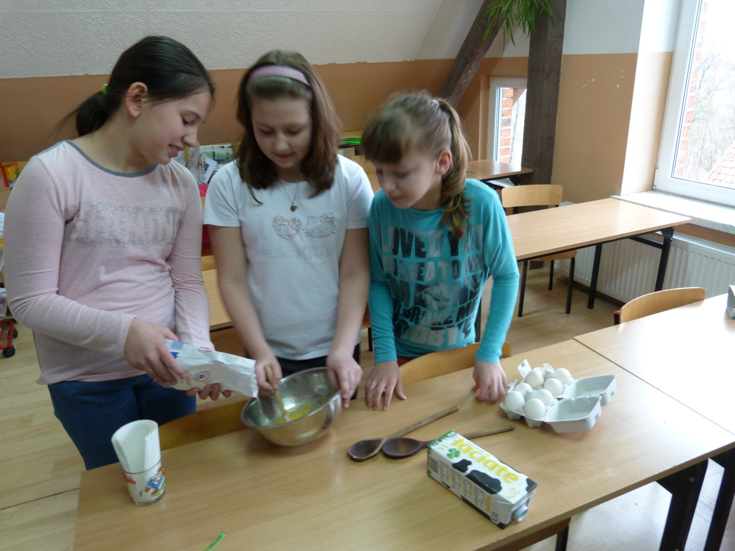

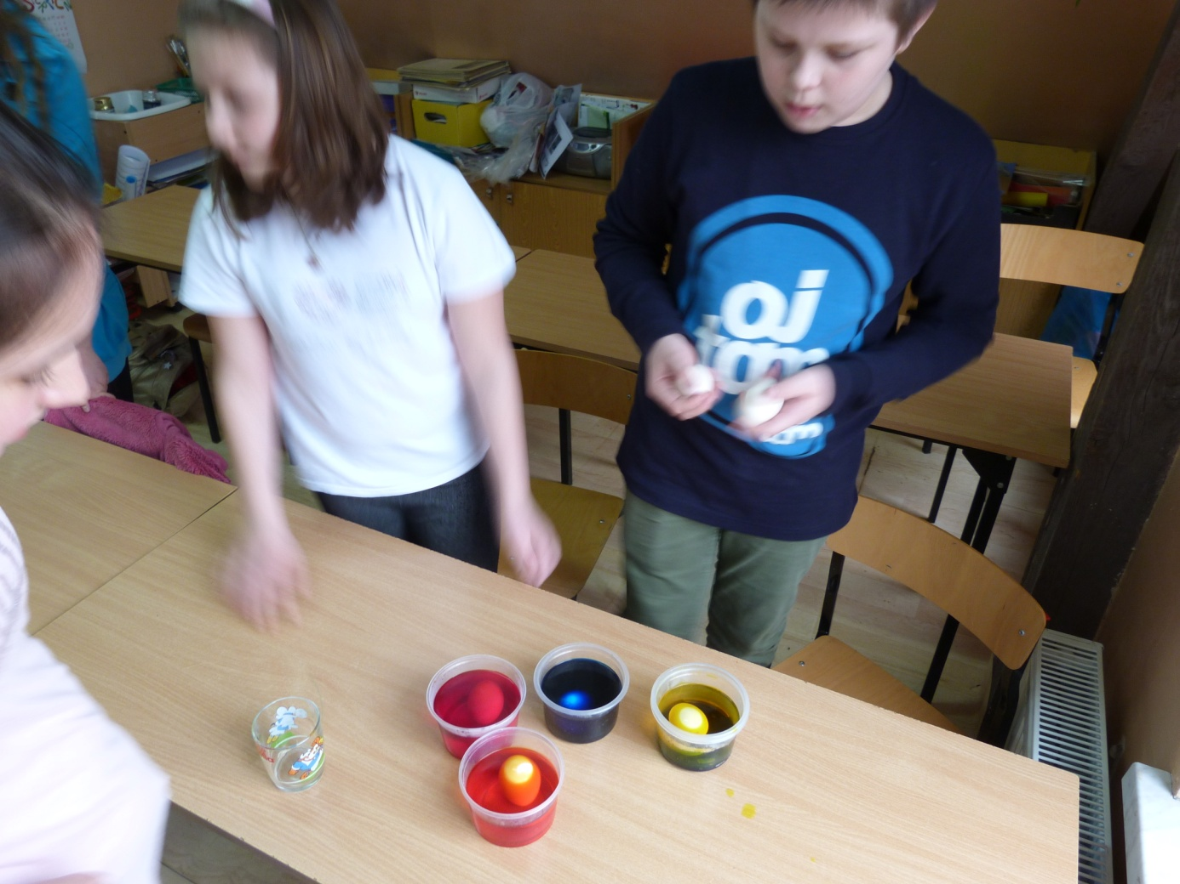

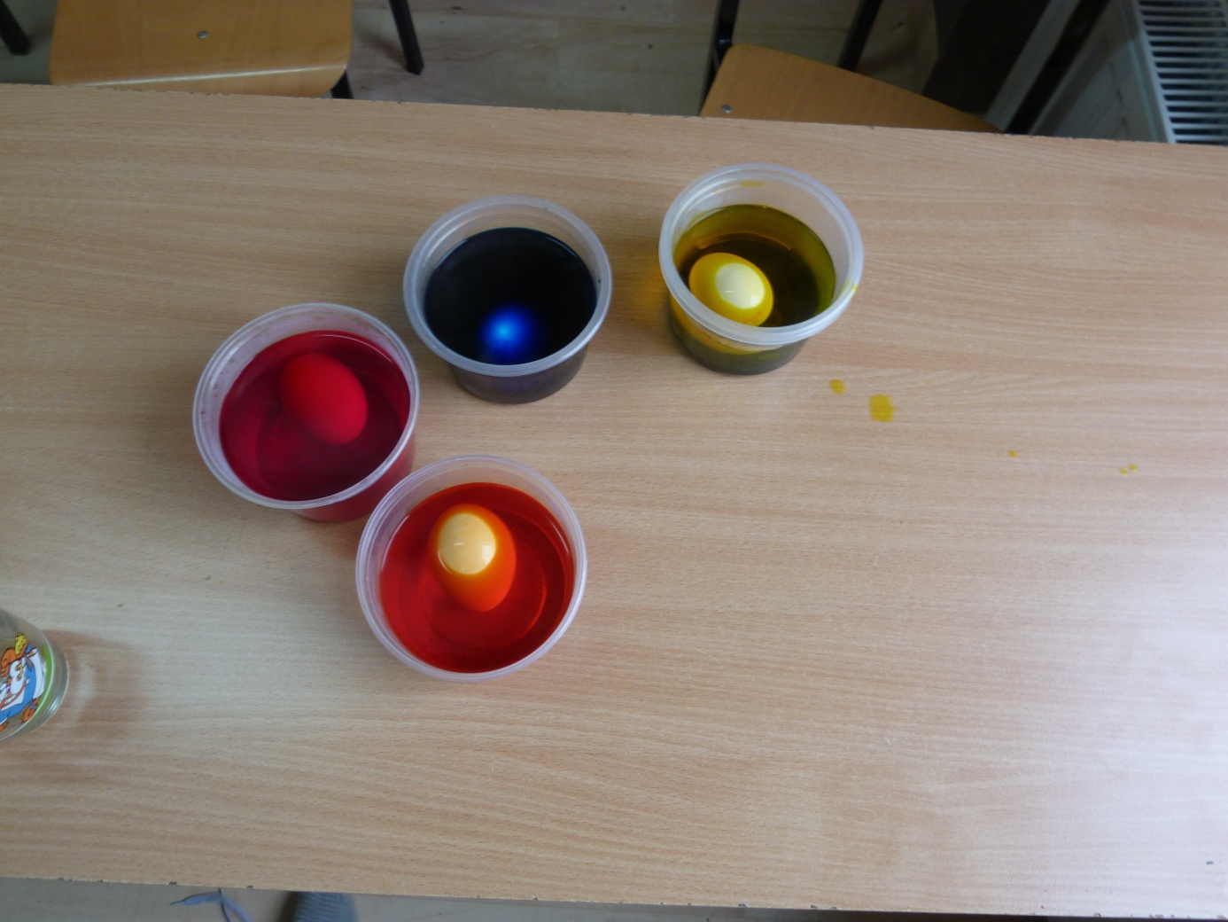

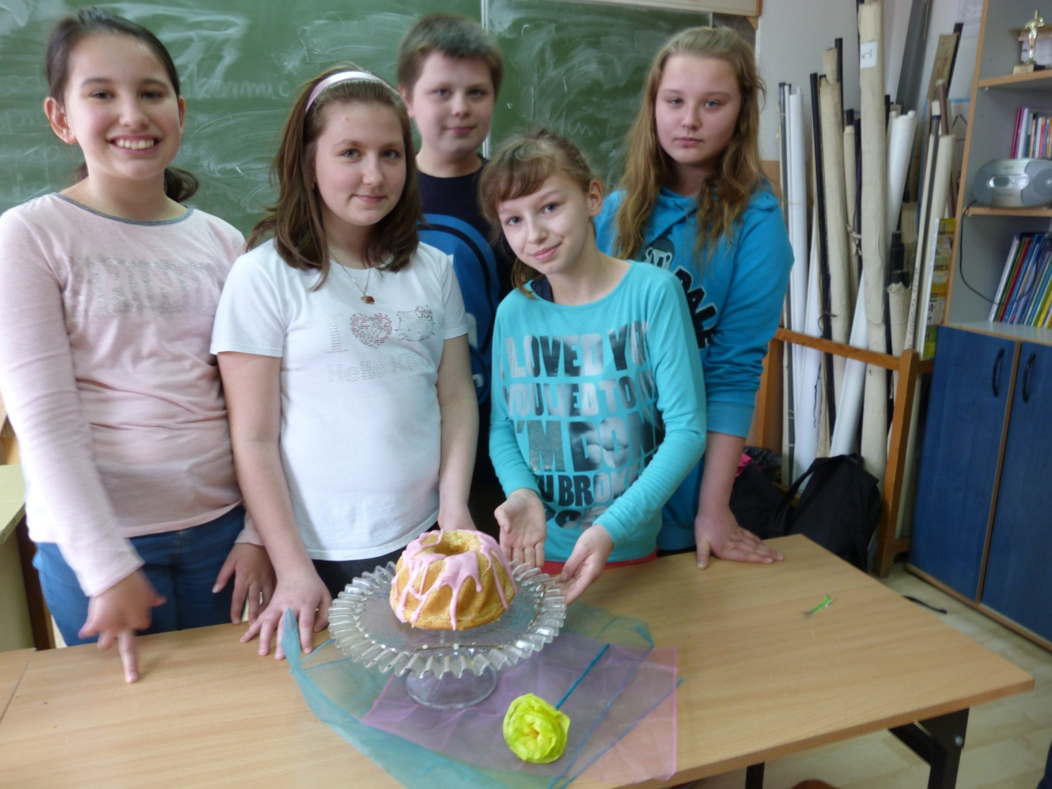

# White Borscht Soup Recipe

White borscht soup -- Polish *bialy barszcz* or *żurek wielkanocny* -- is typically eaten on Easter Sunday morning and is made with most of the foods from the [*swieconka*](http://easteuropeanfood.about.com/od/qz/g/swieconka.htm) basket blessed on Holy Saturday.   
  
The soup ingredients vary by family and region. I make it with sour cream and smoked and fresh white Polish sausage. Others use buttermilk and ham, and my sister-in-law skips the sausage and adds bacon, sauteed onions, vinegar and sugar. What remains constant is the sausage water base and some type of sour known as *żur* or *kwas* as in this traditional [*żurek recipe*](http://easteuropeanfood.about.com/od/polishsoups/r/zurek.htm) from poland.   
  
Here's a larger picture of my version of [white borscht](http://0.tqn.com/d/easteuropeanfood/1/0/b/P/-/-/whiteborscht2x600.jpg).   
  
**Makes 6 servings of Polish White Borscht Recipe**

### Prep Time: 10 minutes

### Cook Time: 30 minutes

### Total Time: 40 minutes

### Ingredients:

* 6 cups sausage cooking water, fat removed
* 1 clove minced garlic
* 2 cups sour cream
* 1/4 cup all-purpose flour
* 1 link white Polish kielbasa sausage, casing removed, sliced 1/4" thick
* 1 link smoked Polish kielbasa sausage, casing removed, sliced 1/4" thick
* 6 medium potatoes, peeled, cut into chunks and boiled
* 6 hard-cooked sliced eggs
* 6 slices light or dark rye bread
* Salt and pepper to taste

### Preparation:

1. In a large pot or Dutch oven, add [sausage water](http://easteuropeanfood.about.com/od/quick4/qt/sausagewater.htm) and garlic. Bring to a boil, reduce heat and simmer, partially covered, for 5 minutes.
2. Fork-blend the flour and sour cream. [Temper](http://easteuropeanfood.about.com/od/qz/g/temper.htm) the sour cream with a little hot sausage water, then return to pot, stirring until thickened. Add sausages, potatoes and eggs to pot and heat until warmed through. Season to taste. At this point, some people add a pinch of sugar or a tablespoon of vinegar. The soup should have a pleasantly sour taste.
3. Into 6 heated bowls, tear [rye bread](http://easteuropeanfood.about.com/od/breads/r/RyeBread.htm) into bite-sized pieces. Ladle hot soup over bread.

**Coloured Easter Eggs**

Here is how to color Easter Eggs using food colors.

### Prep Time: 25 minutes

### Total Time: 25 minutes

### Ingredients:

* eggs
* boiling water
* vinegar
* liquid food colors (green, yellow, red, blue*)

### Preparation:

To hard boil eggs, place eggs in saucepan. Cover with cold water. Cover pot and bring to a boil. Allow eggs to simmer for 15 minutes. Remove from heat and drain eggs. Rinse with cool water.

In coloring eggs, add 1 teaspoon vinegar to 1/2 cup boiling water. Add at least 20 drops of desired color. Dip hard boiled eggs in colored water. The longer in the water the deeper the color. Store eggs in refrigerator.

Colors can be mixed to make other colors. (Yellow and red equals orange, red and blue is purple, and so on.)

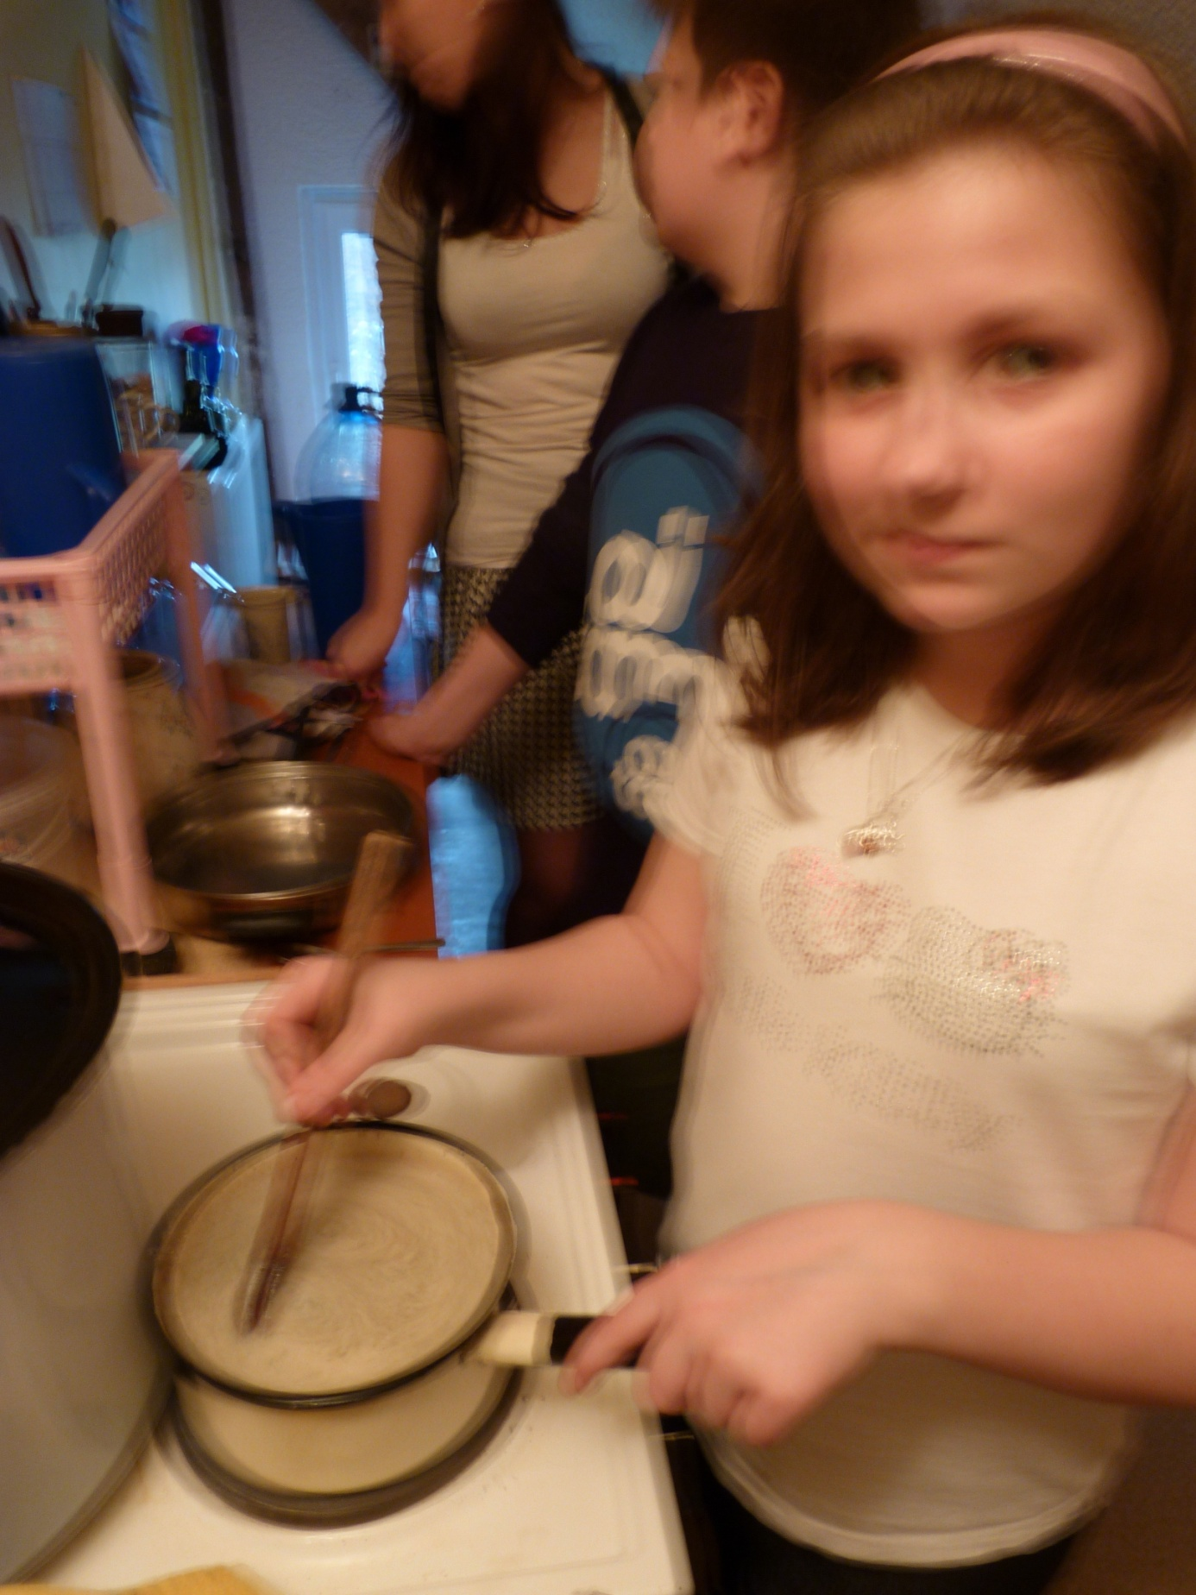

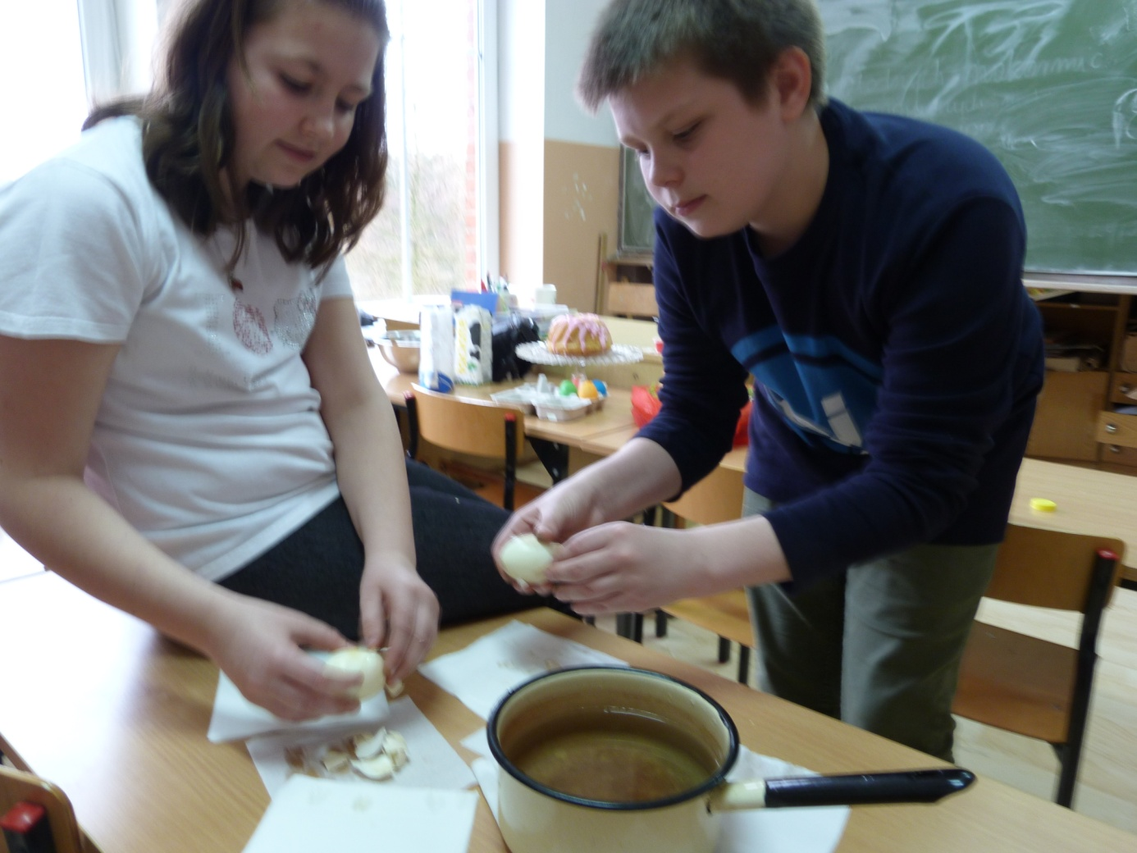

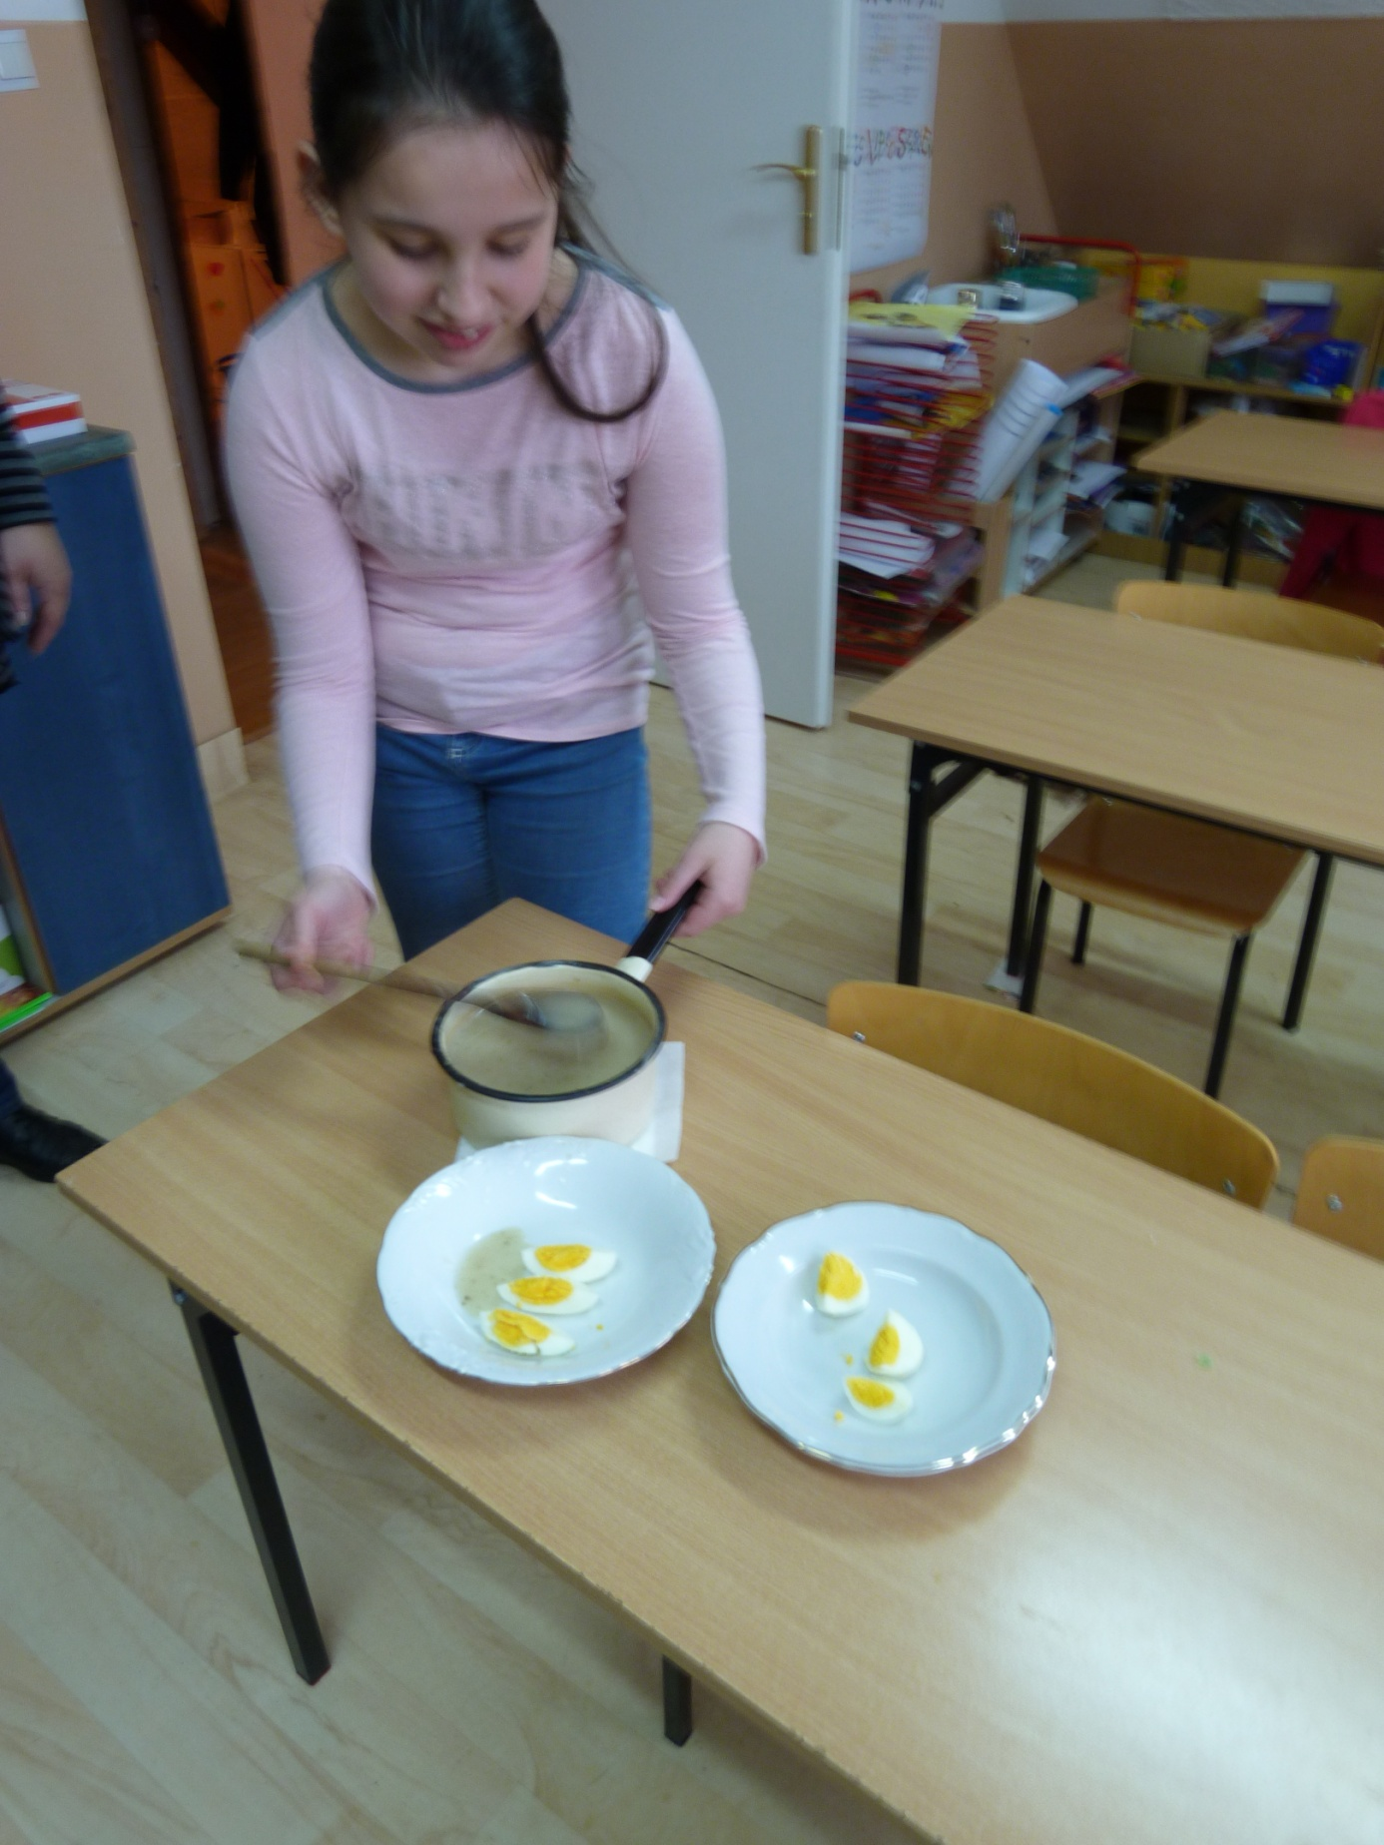

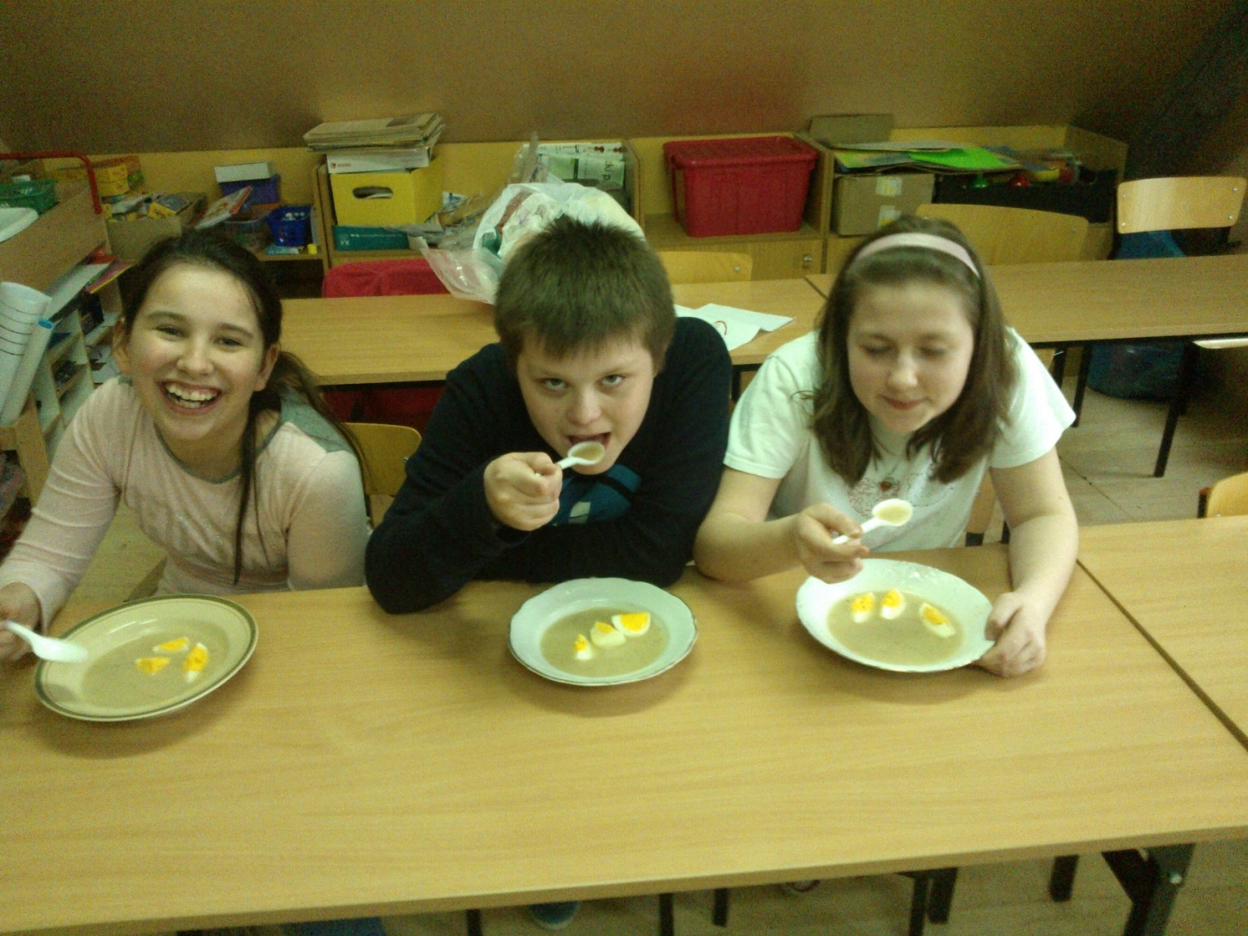

**Chałka – Polish Egg Bread**

This rich, eggy, slightly sweet yeast bread exists in almost every Eastern European culture. Typically, it's braided and can be made with or without raisins. Bohemians and Czechs call it [houska](http://easteuropeanfood.about.com/od/ah/g/hoska.htm). Poles call it [chalka](http://easteuropeanfood.about.com/od/polishbreads/r/Egg-Twist-Bread-Recipe.htm), Ashkenazi Jews refer to it as [challah](http://easteuropeanfood.about.com/od/ah/g/challah.htm). The bread is reminiscent of French [brioche](http://easteuropeanfood.about.com/od/ah/g/brioche.htm) and is terrific plain, with butter or toasted. Leftovers are great in [bread pudding](http://easteuropeanfood.about.com/od/desserts/r/breadpudding.htm) and [makowki](http://easteuropeanfood.about.com/od/desserts/r/poppyseedpuddin.htm).

### Prep Time: 30 minutes

### Cook Time: 30 minutes

### Rising: 2 hours

### Total Time: 3 hours

### Yield: 1 large or 2 medium loaves bread

### Ingredients:

* 1 cup warm milk (no hotter than 110 degrees)
* 4 ounces (1 stick) butter
* 1 cup sugar (or less, to taste)
* 1/2 teaspoon salt
* 2 packages (4 1/2 teaspoons) active dry yeast
* 1/4 cup warm water
* 2 large room-temperature eggs
* 5 1/2 cups all-purpose flour
* 1 cup golden raisins
* 1 large egg beaten with 1 teaspoon water for egg wash

### Preparation:

1. Add butter, sugar and salt to warm milk, stirring to combine. Place yeast and warm water in the bowl of a stand mixer and, with the paddle attachment, stir until dissolved. Add warm milk mixture and 2 eggs, and combine.
2. Add 3 cups flour and beat until smooth. Add the raisins and remaining 2 1/2 cups flour and mix 5 minutes until smooth. Dough will be sticky.
3. Scrape down sides of dough and let rise in same bowl, covered, until doubled, about 1 hour. See this [Quick Tip](http://easteuropeanfood.about.com/od/breads/qt/risetime.htm) for faster rising.
4. With a slightly floured fish, punch down dough and turn out onto lightly floured board. If making 1 large loaf, divide dough into 3 equal pieces. Roll each piece into a strip about 14 inches long, and braid together the 3 strips on a parchment-lined baking pan. **Note:** If making 2 loaves, divide dough into 2 equal pieces and then divide each half into 3 equal pieces, for a total of 6 pieces.
5. Loosely cover bread with greased plastic wrap and let rise until doubled, about 30 minutes. See this [Quick Tip](http://easteuropeanfood.about.com/od/breads/qt/risetime.htm) for faster rising.
6. Heat oven to 350 degrees. [Brush egg wash](http://easteuropeanfood.about.com/od/breads/qt/eggwash.htm) lightly on bread. Bake 30 minutes.
7. Let cool completely before serving. Store, covered, at room temperature or slice and freeze.

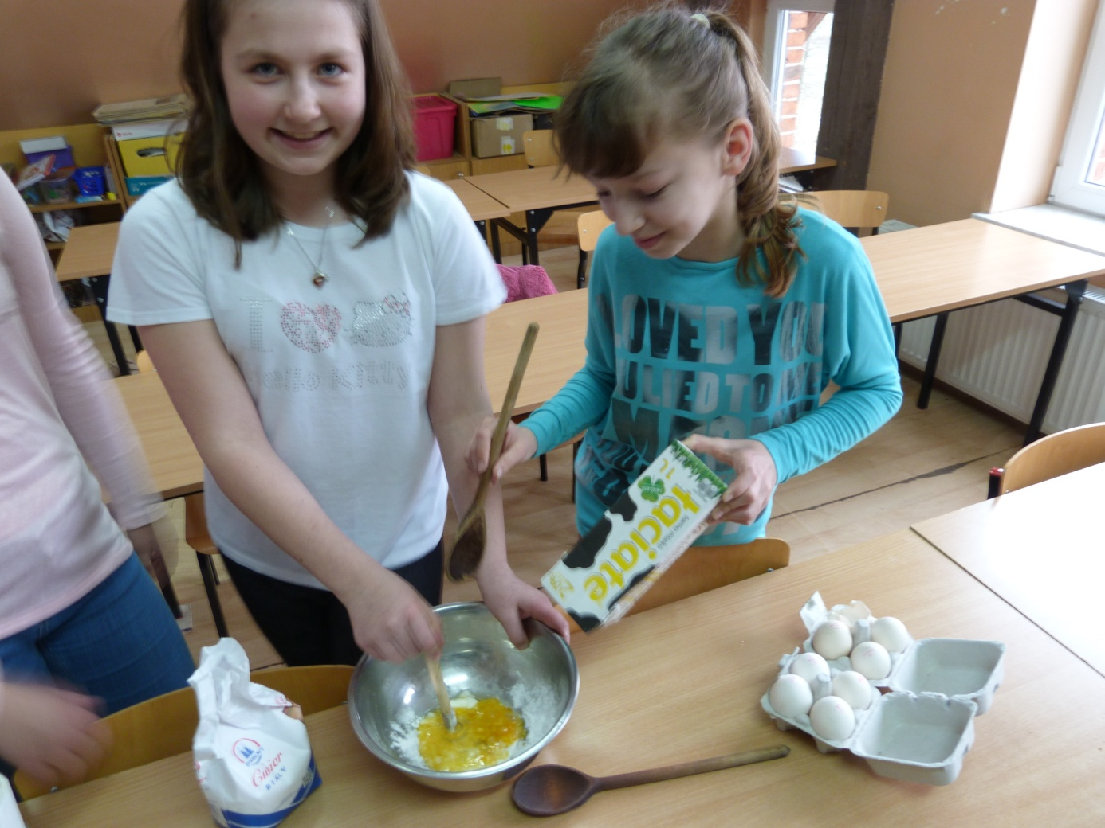

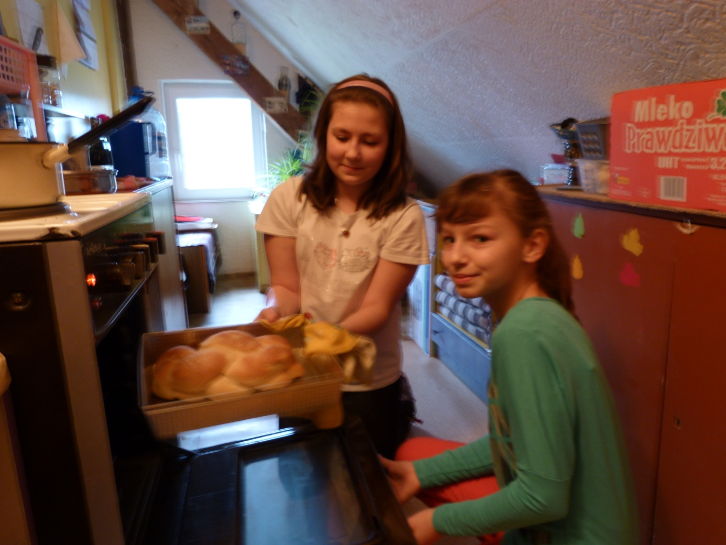

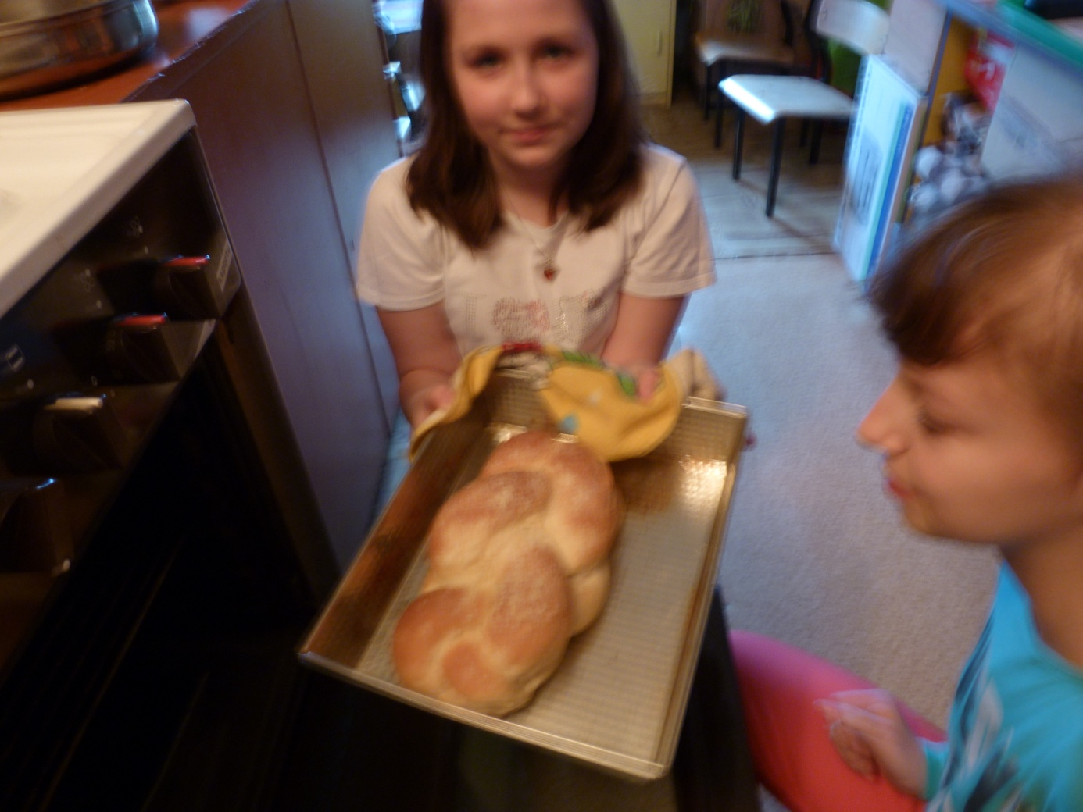

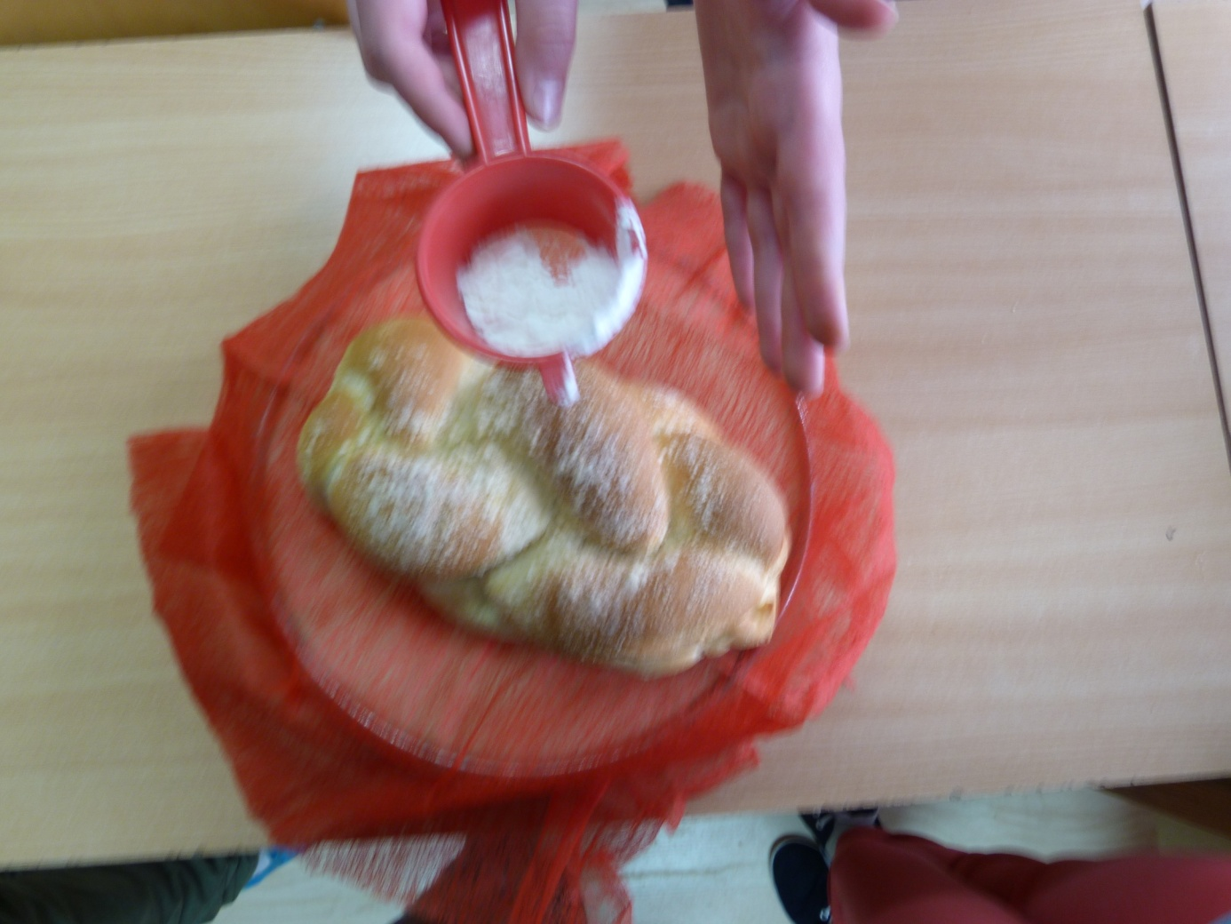

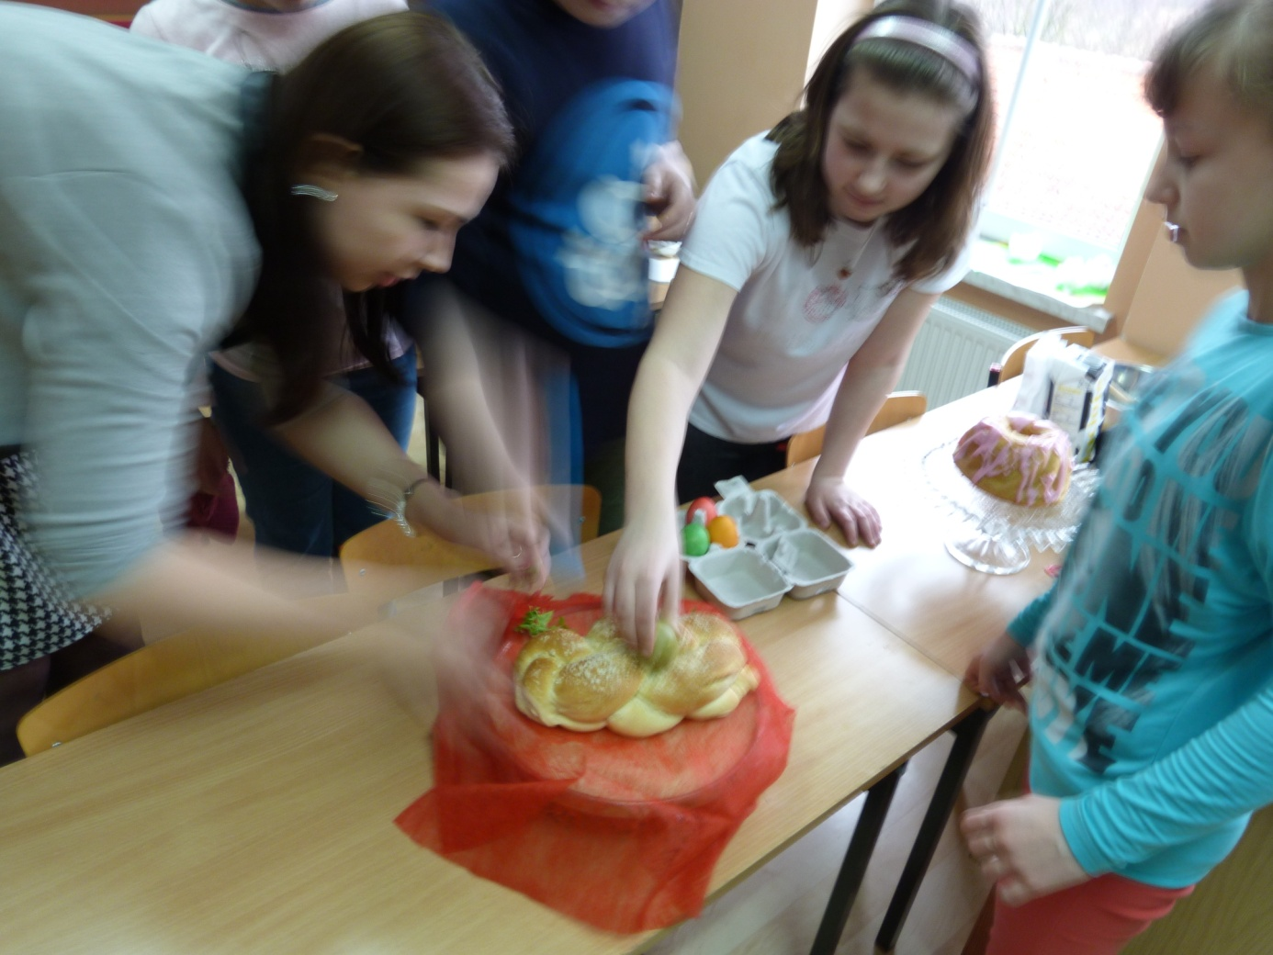

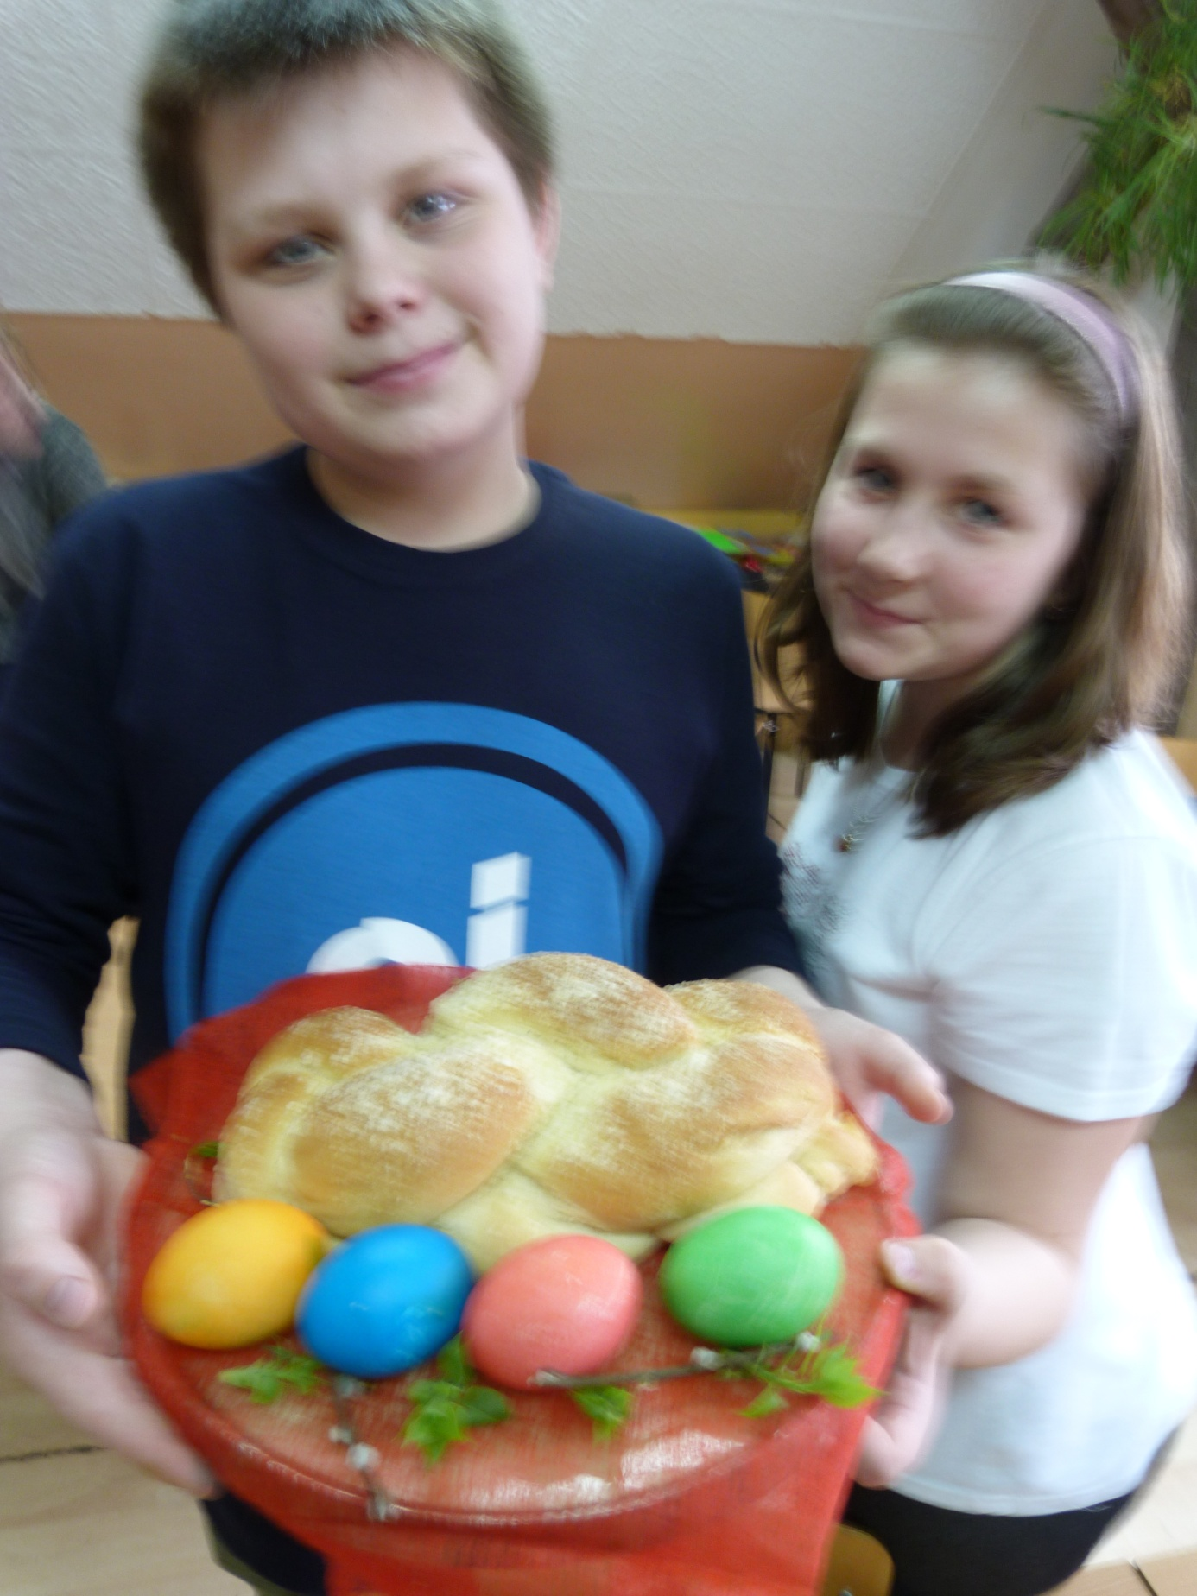

S M A C Z N E G O !!!!!!!!!!!!!!!! ☺