Easter traditions in Latvia
Lieldienas, "The Great Day", "Great Days"
The Easter symbolised coming of spring (it has no important relations with rebirth of the Christ that is celebrated in the world). For Latvians, the Easter symbolises revival of the nature. According to folk tradition Easter has arrived when the day has become longer than the night for the first time that year.
Palm Sunday is Pūpolu svētdiena - little children are awoken that morning by the ritualistic swats of a willow branch and the exclamation, "Apaļš kā pūpols, apaļš kāpūpols!" ("Round like (the catkins of) a pussy willow!")
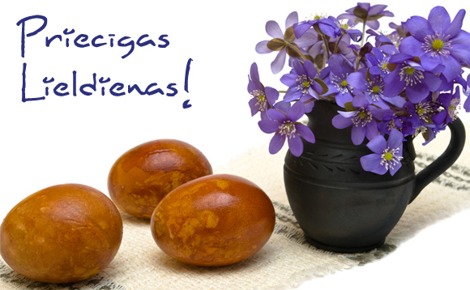
Traditions
- Before the rising of the sun, wash faces in a spring or a stream running east;
On Easter morning people arose before the rising of the sun, and to obtain health and beauty, they hurried to wash their faces in a spring or a streamrunning east.
- Swinging - to spare bites from mosquitoes and gadflies.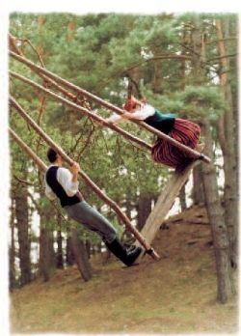
According to archaic beliefs, swinging is connected with fertility, and it must be done, so the livestock will do well, as well as the flax, and one will be spared bites from mosquitoes and gadflies.And you wouldn’t be sleepy head for the rest of the year.

- Colour eggs and knock them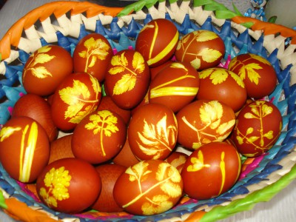

Latvians colour eggs by boiling them in onion skins and tying different materials around the eggs before boiling, which will make patterns on them.
Eggs are knocked together to see which one survives cracking, as according to belief, the one whose egg shell was strongest, will live longer. During Easter, eggs are rolled and eaten in great quantities, because in addition to round flatbreads and sprouted grains, they are the primary Easter foods.
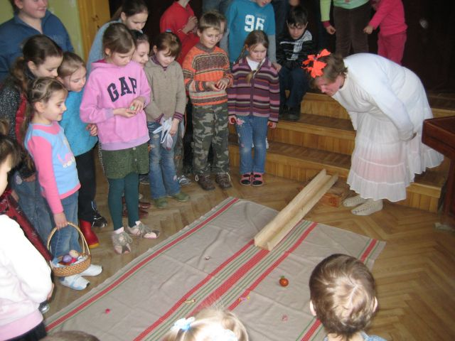
Cuisine
- Eggs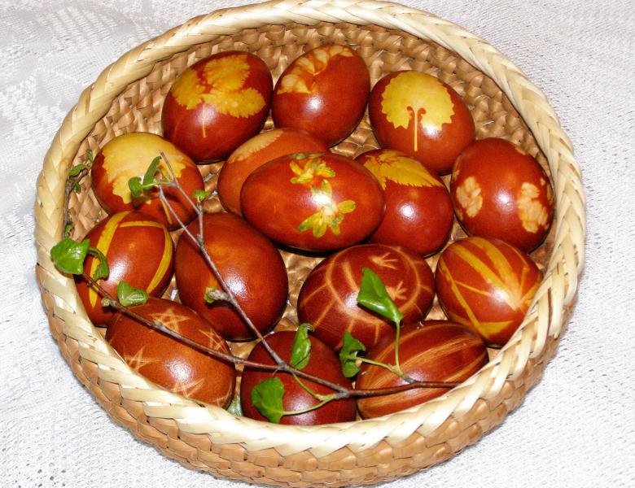
At the time of the spring solstice, or Easter, food stores would usually have been running low, so eggs were saved for some time before Easter. Boiled eggs, coloured with brown onion skins and decorated with scratched designs have been the main Easter food for many centuries. Many families still boil and eat their own home coloured eggs at Easter.

