**Eggs with shrimp**

* Hard boil the eggs
* Cut them in halves
* Put a teaspoon of mayonaise on each half
* Put 2 or 3 peeled shrimps on the mayonnaise
* Decorate with dill and lemon

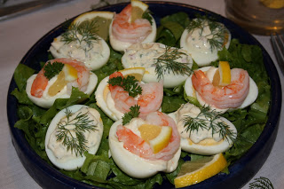

Gubbröra (Old man’s mix)

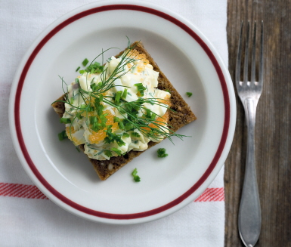

* 1 onion
* 1 tablespoon butter
* 4 hard boiled eggs
* 55 g anchovise (or herring)
* 2 tablespoons chopped chives
* 2 tablespoons chopped dill
* Black pepper

**Do this:**

Peel and chop the onion. Fry it in butter and let cool. Peel and chop the eggs. Chop the anchovies/herring. Mix all the ingredients and add black pepper to taste. Serve on rye bread.

**SERVERI**

**Gravad lax (cured salmon)**

* 1 kilo fresh salmon (boneless)
* 1⁄2 dl salt
* 1 dl sugar
* 1 msk crushed white peppercorns
* 1⁄2 dl chopped fresh dill

**Do this:**

Put the salmon in the freezer fot at least 24 hours.

Mix salt, sugar and pepper. Massage it into the salmon-meat, put the dill on top. Cut the salmon in two and put the two meaty parts together, facing each other. Put the salmon in a plastic bag and keep it in the fridge for 2 days, turn the bag 4-5 times during the 2 days. Scrape off the dill and the spice and slice the salmon in thin slices. Enjoy!

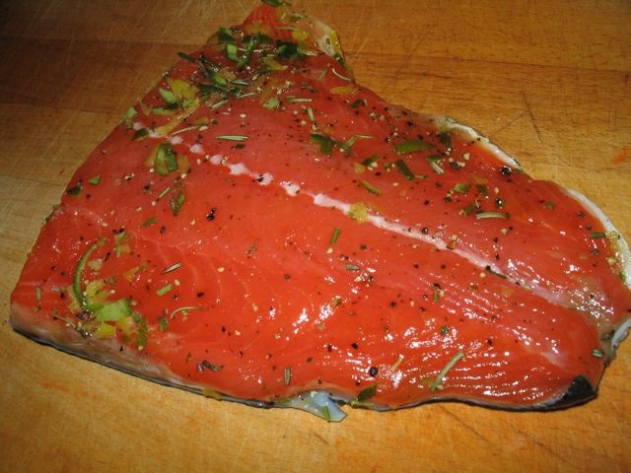

Easter cakes.

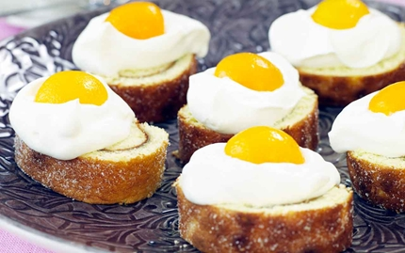

Makes 10

**Ingredients**

* 3 eggs
* 1 1⁄2 dl sugar
* 2 dl flour
* 1 tea spoon baking soda
* 1 table spoon water

**Filling:**

* 2 dl jam or applesauce

**Decoration:**

* 3 dl whipping cream
* 1 can of apricots or peaches

**Do this:**

Put the oven on 225°. Put a sheet of baking paper in a roasting pan (for the oven). Approx 30x40 cm. Whip eggs and sugar until white and fluffy. Mix flour and baking soda with the eggs and sugar. Add water. Pour the batteri nto the pan and bake in the oven for 7 minutes.

Remove the paper from the cake. Put the jam on the cake and roll it together. Cut the roll in 10 pieces. Whip the cream. Put cream and fruit on each piece, making it look like an egg.