Laboratory – Construction and calculation of road vehicles
Faculty of Engineering Hunedoara

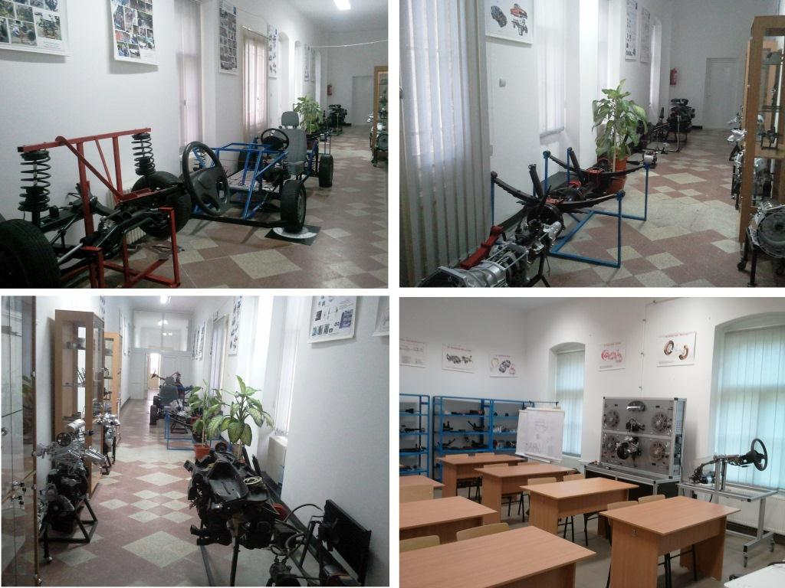

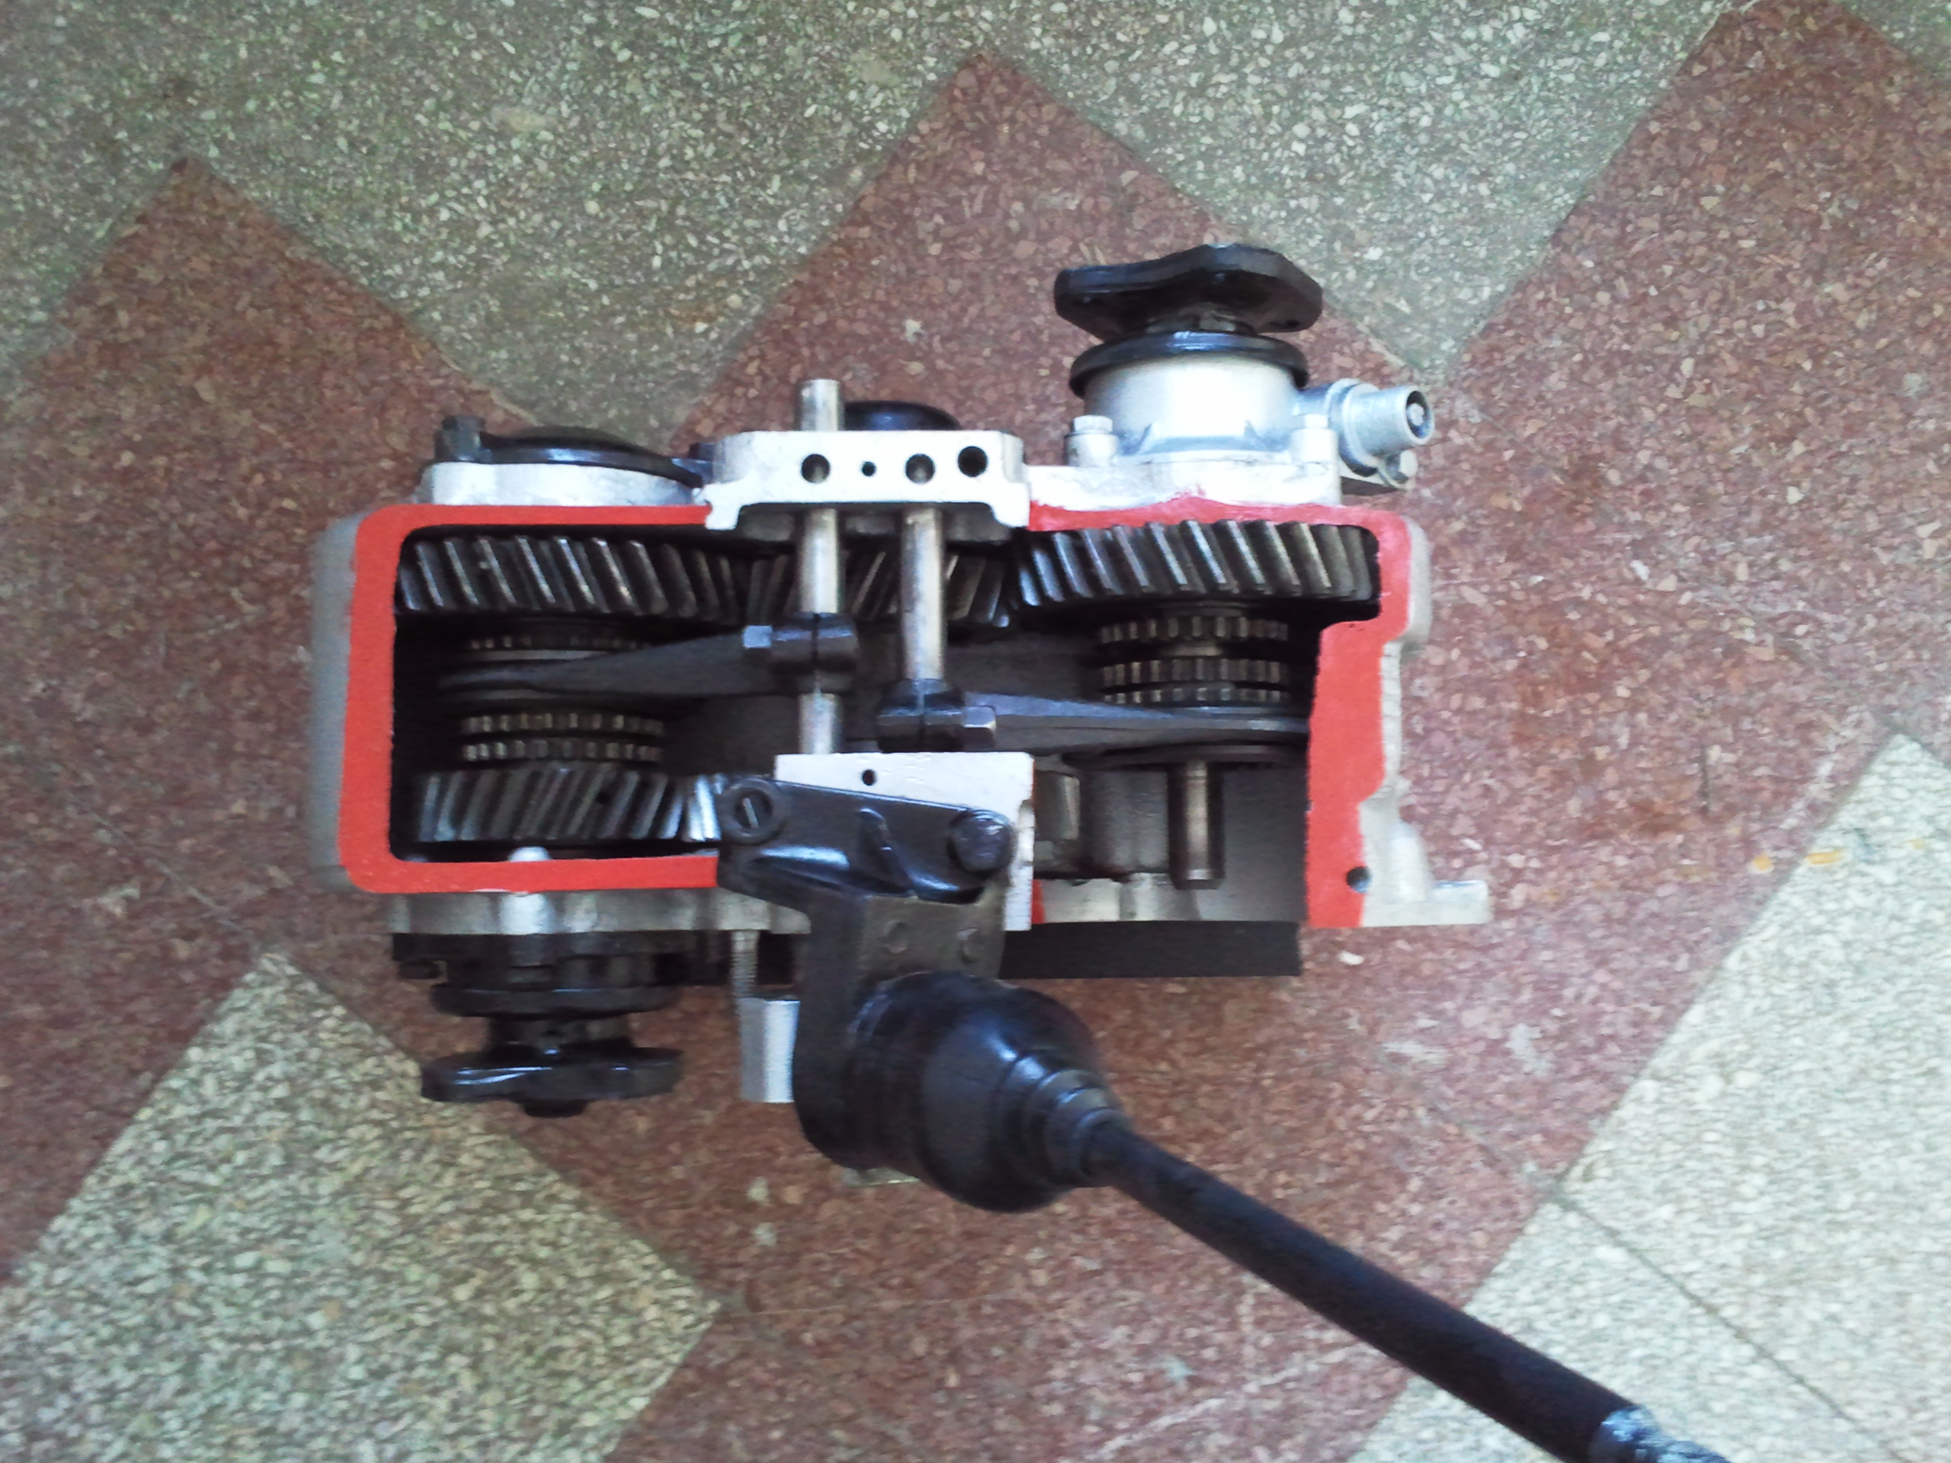 | 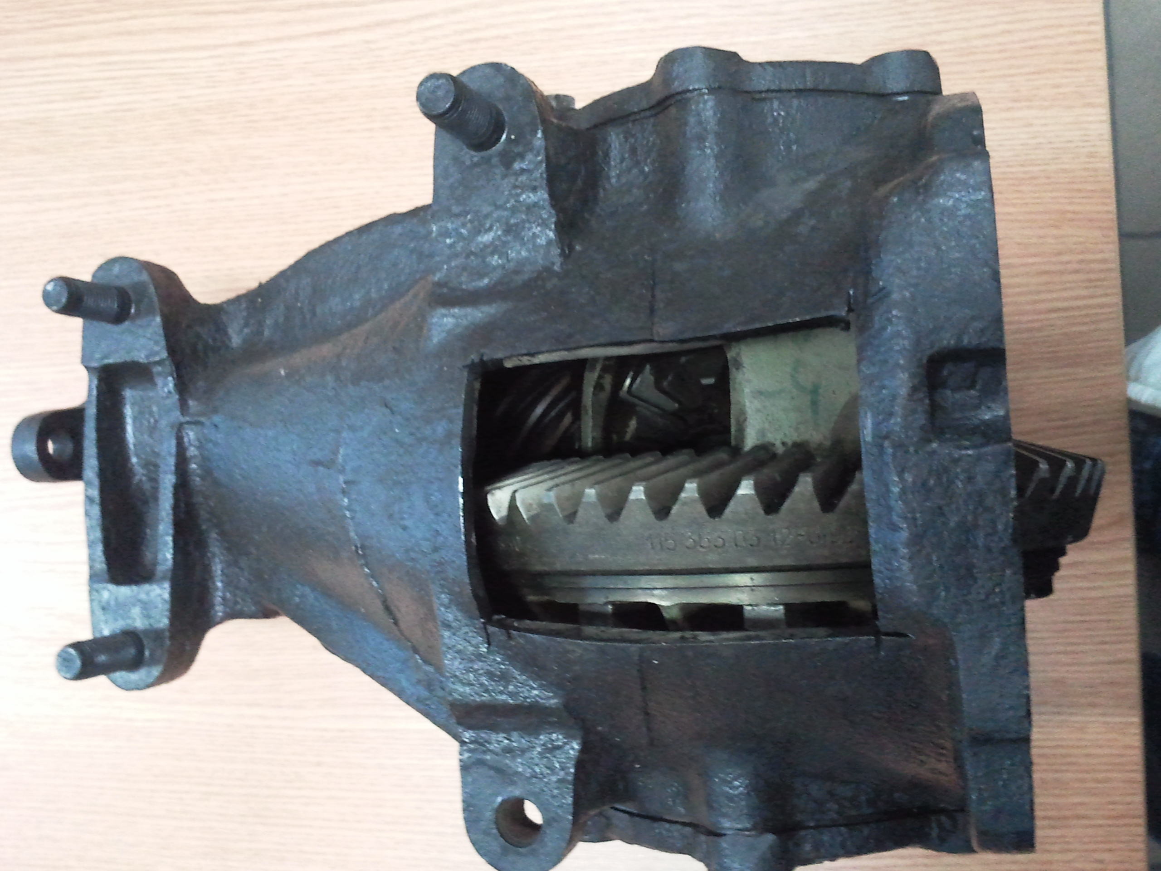 | 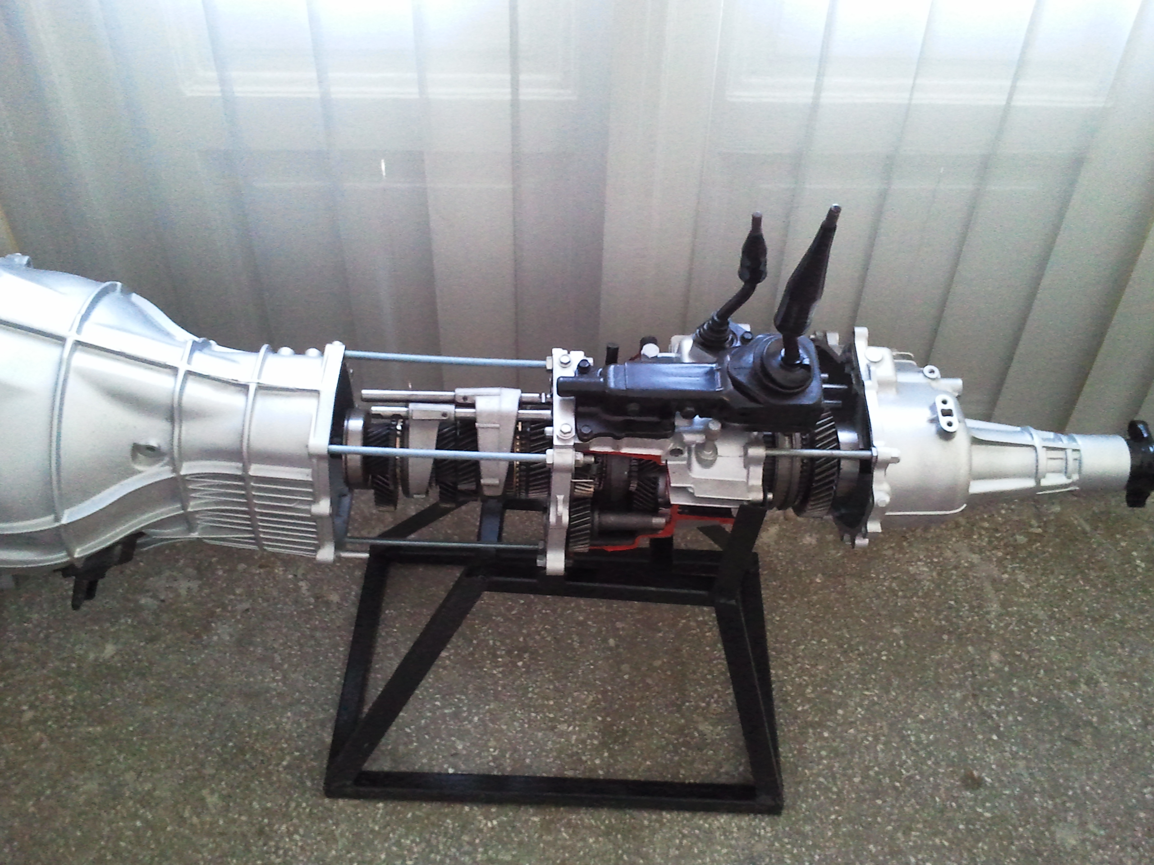
Reduction distributor ARO 240 | Symmetrically interaxial differential | Reduction distrubuitor Opel Frontera 4x4 drive

Didactical stand for study Anti-lock Brake System - Golf V
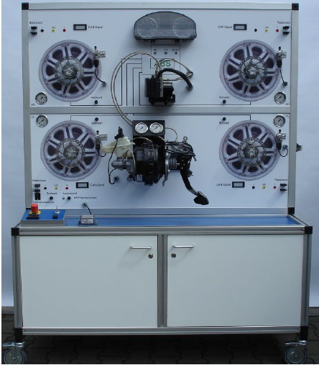
Standul didactic pentru studiul sistemului de frânare asistat

Principle
ABS is based on the physical fact that maximum braking deceleration is achieved at around 10-30% wheel slip, depending on the road conditions. 20% brake slip means that in the same period the vehicle takes to cover a distance of one metre, the wheels only roll 0.8 metres. If the maximum braking force that can be applied is exceeded,
the braking force that can be applied drops, the wheels lock (=100% brake slip) and in the locked state are only retarded by sliding friction that is typically around 15 to 20 percent less than the static friction (depending on the tyre type). Furthermore, on locking there is uneven abrasion on the tyre (flat spot from braking), it is very difficult to control the vehicle and inexperienced drivers rarely react correctly in this situation (correct would be to immediately reduce the braking force until the wheels start to turn again).
The ABS regulates the braking force at each wheel such that the slip during the braking operation remains as close as possible to the optimum limit.
The central component in the Bosch brake assist system is the hydraulic unit with the integrated ABS control unit and the return flow pump. The brake pressure sender in the hydraulic unit, the speed sensors and the brake light switch supply signals to the brake assist system so that it can identify an emergency.
Pressure is raised in the brake slave cylinders by the actuation of certain valves in the hydraulic unit and the return flow pump for TCS/ESP.
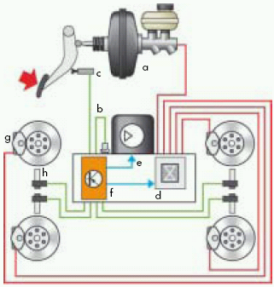
a - Brake servo; b - Brake pressure sensor; c - Brake light switch; d - Hydraulic unit; e - Return flow pump; f - Control unit; g - Brake slave cylinder; h - Speed sensor

Comparison...
The vehicle without a brake assist system attains the ABS regulation range later than the vehicle
with a brake assist system and consequently has a longer brake path.
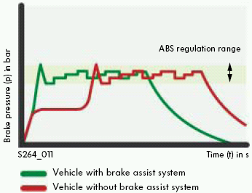

Electro-mechanical power steering with dual pinion

The steering system components are:
- Steering wheel
- Steering column switch with steering angle sender G85
- Steering column
- Steering moment sender G269
- Steering gear
- Electro-mechanical power steering motor V187
- Power steering control unit J500

General overview of electro-mechanical power steering with dual pinion
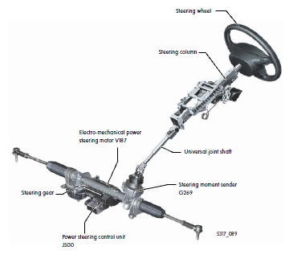
The electro-mechanical power steering and its individual parts

