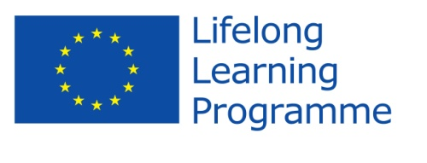

**Comenius Project**

**United Europe - a perfect home to live in.**

**Initial Questionnaire for students**

**Answers from Latvia**

1. *Do you consider this project as*
   * a teachers' project
   * a students' project
   * a school’s project -100%
2. *Where did you learn about the programme?*
   * from my teachers -100%
   * from my friends
   * from Internet
3. *Do you think that your participation in the project will help you to increase your foreign language skills?*
   * *Yes -100%*
   * *No*
4. *Do you think the project is valuable in helping to improve attitudes towards people from different countries?*
   * *Yes - 100%*
   * *No*
5. *Are you proud of being a member of the team?*
   * *Yes - 100%*
   * *No*
6. *Can you name the rest of the countries which participate in the project with you?*

*All students can name the participating countries - Romania, Sweden, Poland, Bulgaria*

1. Name two facts about the participating countries. What comes to your mind when mentioned of those participating countries?

There are all countries in the European Union. 100%

Sweden – Stockholm - 5 answers

The ferryboat “Tallink” (from Riga to Stockholm) -5

World Hockey Championship last year -7

Snow -3

Eurovision-1

Writer Astrid Lindgren and her books about Carlson -3

Poland - Europe Football Championship last year -5

Warsaw -2

Food -2

Apples -6

Many Churches -3

Actor Paul Wesley's family comes from Poland -3

Romania – the mountains - 5

Gardens of grapes -4

Transylvania, Dracula and vampires -12

The folk tradition of songs and dances -1

Bulgaria - The Black Sea -12

The folk tradition of songs and dances -3

1. Can you name the participating countries with their capital cities?

The students can name the capitals of countries – 100%

1. Try to find 3 similarities between you and your project partners.

We are in the European Union. – 17answers

Try to learn English. - 13

Our Comenius project - 9

Many schools - 6

The folk traditions have been preserved – 3

Travelling - 5

1. What do you expect from this project? Express your opinions shortly.

To meet other children – 8 answers

To make new friends - 11

To get to know the folk traditions - 5

To gain new knowledge - 5

The excursions and the sightseeing - 6

To learn new languages -11

Understanding with all people and friendship -2