Potato pancakes
Ingredients: 5 potatoes, 1 cup of milk, 2 eggs, 1 onion, wheat flour, salt and pepper.
Preparation: Peel potatoes and grate finely, squeeze off the potato juice (put it aside in a separate bowl) Now you need to be pretty fast – cover the potato mass with boiling milk to prevent them from getting dark. Take the bowl with potato juice and carefully pour off the liquid until you see starch in the bottom. Add the starch to the potato mass. Add eggs, salt and pepper and still well. Add finely chopped onion. Add wheat flour to make dough more thick. Fry pancakes in preheat oil from both sides until golden. Eat hot with sour cream or red bilberry jam.

Whipped cranberry dessert with milk
Ingredients:
1 cup cranberries (or any other berries) 1/2 cup sugar 1/2 cup semolina 1 litre of water
Preparation:
Cranberries cooked in a small amount of hot water. Add sugar. Slowly add to semolina. Stir and cook over about 10 minutes. Cool in a cold water bath, then with mixer beat together until the mass remains bright and strong. Pour the milk.
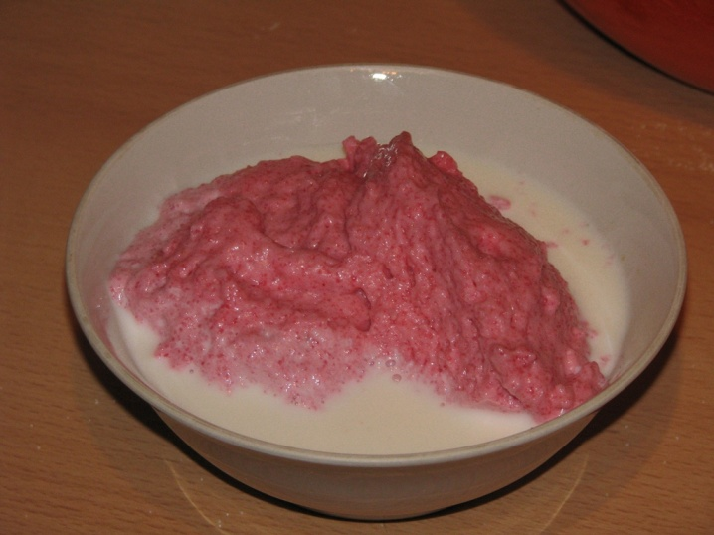

Potato salad
Ingredients:
5 boiled potatoes
1 large boiled carrot
3-4 boiled eggs
Boiled sausage + (optional) dried sausage)
4-5 medium-sized pickled cucumber
1 tin of pickled green peas
Mustard; mayonnaise; pepper; salt;
Preparation:
Potatoes, sausage, cucumbers, carrot, eggs cut in small cubes. Add green peas.
Add mustard (can be more or less - it's a matter of taste) and one packet of mayonnaise.
Add salt and pepper. Mix everything.
You can append one or two very, very finely sliced ​​apples, a bit of fresh cucumbers, and a variety of greens.
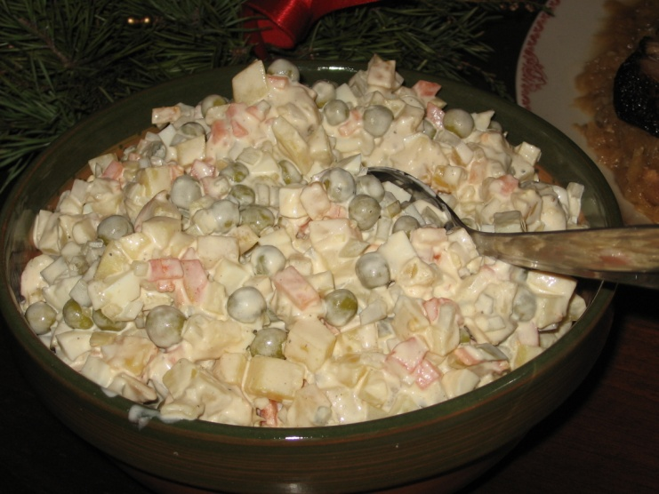

Cottage cheese doughnut
Ingredients:
500 g of cottage cheese, 5 eggs, 500 g sugar, 800 g flour, ½ tsp. soda
All ingredients thoroughly knead, make little balls and cook them in a preheat oil.
Served chilled and sprinkle it with powdered sugar.

Sorrel soup
Ingredients:
500g pork
400g sorrel
3 potatoes
1 carrot
1 onion
2 litres water
Salt, sugar
Directions: Pork boiled in water, add fat-fried, chopped onion and carrot, and small, thinly sliced ​​potatoes. When the potatoes soft, add the sliced ​​sorrel, salt, a little sugar and ready-to-cook soup. Add boiled egg. Serve with sour cream.
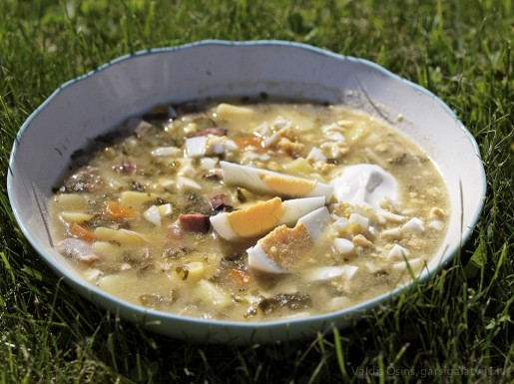
Enjoy!

