Middle School No. 1 .Barczewo
School without a name is like a man without a name . On the surface, can be realized , but it lacks a specific identity. The same is true with the school. Name connects families , and having a patron connects the whole school community . The choice of the patron was a difficult decision , because we made it on behalf of future generations of students who will attend our schools . History has given us a great opportunity and also a huge responsibility - to those who come after us.
Time in school is a very important period in the life of a young man . Here is shaped character and different attitudes towards life , and also builds up a hierarchy of values.
What patterns looking for modern youth ? What support do we need teachers ? What patron connects the common choice of the family and our environment ? These are difficult questions that we asked ourselves when choosing a patron of Our Middle School .
We could not find a pattern that liked by everyone , which is why we have included in our name and the great people who lived on this earth and the ordinary who represent our nation , because we are aware that not every student will be a great poet , an explorer and scientist , but anyone can get your pole and discover your star .
In our name is nature, Warmia forests and lakes , cottages and storks , golden fields of grain, the red roofs of Warmia and iron chapels , wayside crosses . In our name is the past and tradition . There is no place in our environment , which would not be a witness to history. The past is present in everyone , what made ​​our predecessors . It is also present - everything that we are doing, as well as the future - both ours and is very remote , that will always be associated with the Warmia .
Our Middle School from its beginnings cultivates the traditions of our region. Particularly cares about is that graduates are aware of the benefits of regional culture and be able to present values ​​of their town . For our students , our school created a piece of Warmia and cottages for many years organizing the celebration of the land (visit Szemle and servant, Family Day after warmińsku , fit middle school after warmińsku ) , tours of the most beautiful corners of Warmia and competitions related to our region . As teachers and parents we realize that the only man who knows his own environment , its own region may be open to other than our cultural heritage .
Therefore, Educative Program is a vision of our Gymnasium . There is a record , which among other things, we aim :
" A student who completes our school is attached to the Warmia and Polish , thinks in terms of a citizen of Europe and the World ... "
Close identification with the environment , a sense of rootedness and belonging to a particular community , culture can prevent the unit from being lost in today's complex world .

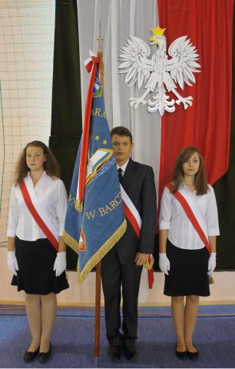

Workshops FAST READING AND TECHNIQUES memory
Coming to the workshop the student will measure your pace of reading, know the most common mistakes reading and find out how to eliminate them , perform some basic exercises , through which the change in reading habits , will accelerate the pace of reading as much as 100 % in complete understanding ! Workshops for students of School No. 1 in Barczewo are unpaid , are held on Tuesdays , from 1400 to 1500 hours
workshops Library
By participating in activities you can be a teacher assistant librarian. Classes are held in individual , at times agreed upon with the librarian . Details of the SCI
ceramic workshops
In class , students learn the techniques of modeling manual decorative and utility work in clay . Workshops are held on Fridays , in hours . From 1400 to 1600 . The work takes part in exhibitions organized by the municipality Barczewo . Some of the work is taken home. Classes are funded by the Municipal Commission of Alcohol-Related Problems

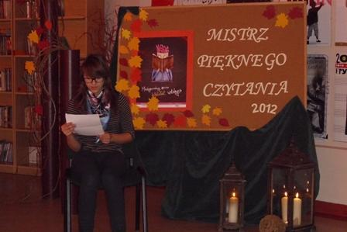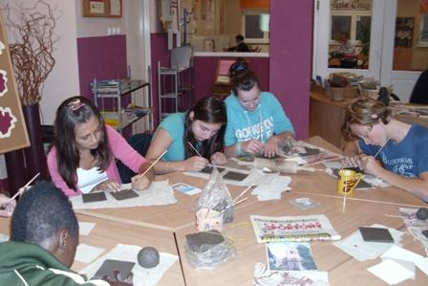

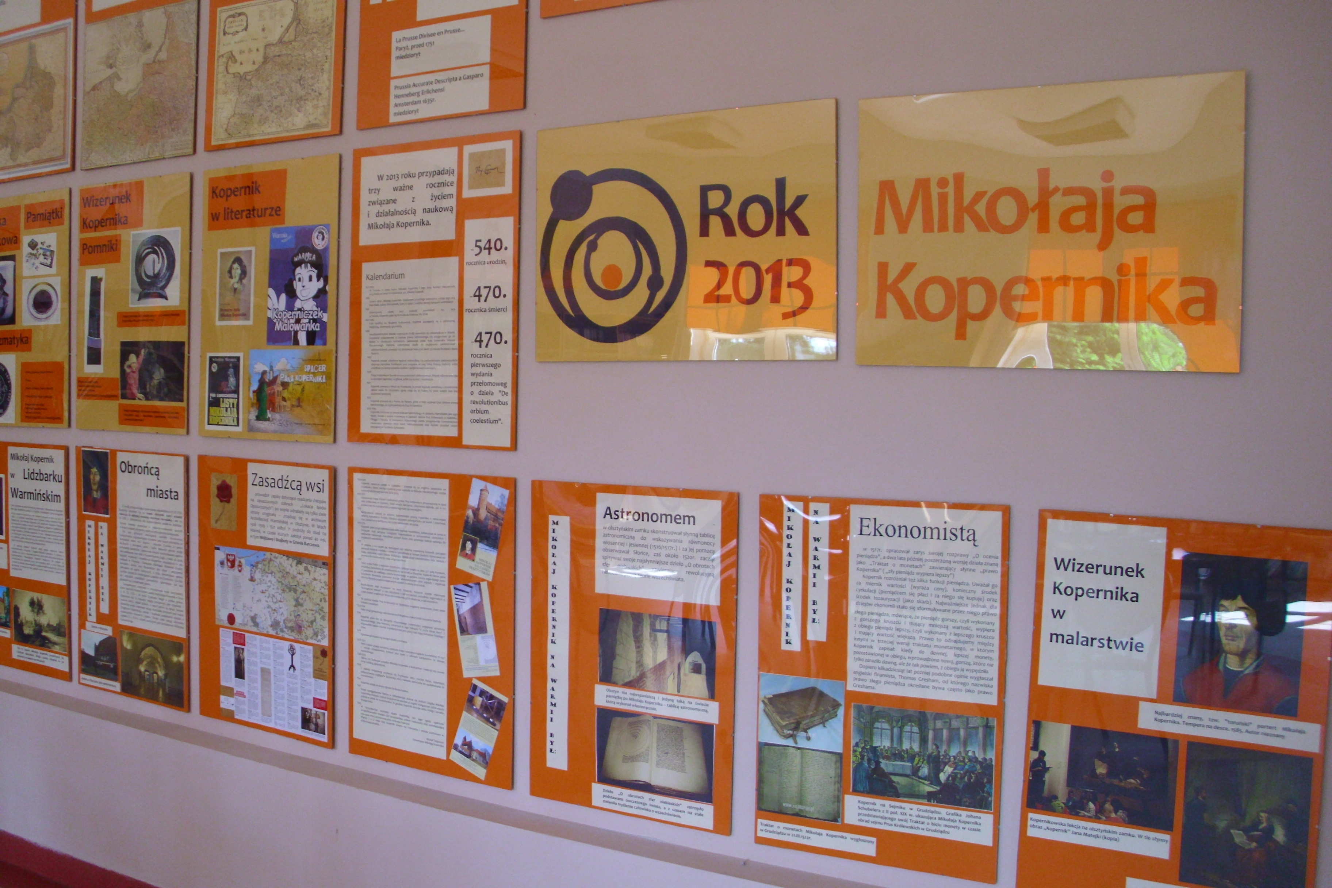
Some Photos

