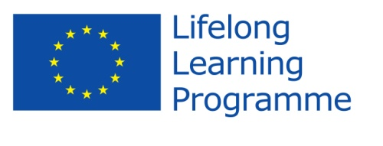

**Comenius Project**

**United Europe - a perfect home to live in.**

**Initial Questionnaire for students**

**RESULTS FROM POLAND**

1. *Do you consider this project as*
   * a teachers' project
   * a students' project
   * a school’s project  **100%**
2. *Where did you learn about the programme?*
   * from my teachers **100%**
   * from my friends
   * from Internet
3. *Do you think that your participation in the project will help you to increase your foreign language skills?*
   * *Yes* ***100%***
   * *No*
4. *Do you think the project is valuable in helping to improve attitudes towards people from different countries?*
   * *Yes* ***100%***
   * *No*
5. *Are you proud of being a member of the team?*
   * *Yes* ***100%***
   * *No*
6. *Can you name the rest of the countries which participate in the project with you?*

*........Sweden............................................................................*

*.........Bulgaria...........................................................................*

*.........Latvia...........................................................................*

*.........Romania...........................................................................*

1. Name two facts about the participating countries. What comes to your mind when mentioned of those participating countries?

* Dracula in Romania
* Swedish buffet
* Ice hockey is popular in Sweden
* People dance Penguin dance in Romania
* Romanian currency is Lei
* In Latvia they have a famous castle
* Roses are the symbol in Bulgaria
* You have to take a ferry to go to Sweden, or a plane
* The countries don’t have euro

1. Can you name the participating countries with their capital cities?

Romania – Bucharest

Latvia – Riga

Sweden- Stockholm

Bulgaria - Sofia

1. Try to find 3 similarities between you and your project partners.

* We don’t have euro
* Children learn English at schools
* We are all European countries with similar nature, fields, rivers
* We have similar traditional clothes

1. What do you expect from this project? Express your opinions shortly.

* To learn about the partners’ schools
* To learn about other cultures / traditions / food
* To improve language skills
* To meet new people / start new friendships
* To visit different countries
* To become less shy / more self-confident
* To have a great fun!

Thank you!