Sibiu

Sibiu is a city in Transylvania, Romania, with a population of 147,245. Located some 215 km (134 mi) north-west of Bucharest, the city straddles the Cibin River, a tributary of the river Olt. Now the capital of Sibiu County, between 1692 and 1791 and 1849-1865 Sibiu was the capital of the Principality of Transylvania.
Sibiu is one of the most important cultural centres of Romania and along with the city of Luxembourg, it was designated a European Capital of Culture for the year 2007. Formerly the centre of the Transylvanian Saxons, the old city of Sibiu was ranked as "Europe's 8th most idyllic place to live" by Forbes.
The city administers the Păltiniş ski resort.
History
The first official record referring to the Sibiu area comes from 1191, when Pope Celestine III confirmed the existence of the free prepositure of the German settlers in Transylvania, the prepositure having its headquarters in Sibiu, named Cibinium at that time. A large part of German settlers were fugitives, convicts and poor people looking for lands and opportunities.
In the 14th century, it was already an important trade centre. In 1376, the craftsmen were divided in 19 guilds. Sibiu became the most important ethnic German city among the seven cities that gave Transylvania its German name Siebenbürgen (literally seven cities), and it was home to the Universitas Saxorum, the assembly of Germans in Transylvania.
During the 18th and 19th centuries, the city became the second and later the first most important centre of Transylvanian Romanian ethnics. The first Romanian-owned bank had its headquarters here (The Albina Bank), as did the ASTRA (Transylvanian Association for Romanian Literature and Romanian's People Culture). After the Romanian Orthodox Church was granted status in the Habsburg Empire from the 1860s onwards, Sibiu became the Metropolitan seat, and the city is still regarded as the third most important centre of the Romanian Orthodox Church. Between the Hungarian Revolution of 1848 and 1867 (the year of the Ausgleich), Sibiu was the meeting-place of the Transylvanian Diet, which had taken its most representative form after the Empire agreed to extend voting rights in the region.
After World War I, when Austria-Hungary was dissolved, Sibiu became part of Romania; the majority of its population was still ethnic German (until 1941) and counted a large Romanian community, as well as a smaller Hungarian one. Starting from the 1950s and until after 1990, most of the city's ethnic Germans emigrated to Germany. Among the roughly 2,000 who have remained is Klaus Johannis, who is currently mayor of Sibiu City.
Geography
The city is about 20 km from the Făgăraş Mountains, 12 km from the Cibin Mountains, and about 15 km from the Lotrului Mountains, which border the depression in its southwestern section. The northern and eastern limits of Sibiu are formed by the Târnavelor Plateau, which descends to the Cibin Valley through Guşteriţei Hill.
The Cibin river as well as some smaller streams runs through Sibiu. The geographical position of Sibiu makes it one of the most important transportation hubs in Romania with important roads and railway lines passing through it.
Economy
Sibiu is one of the most prosperous cities of Romania, and also receives one of the highest rates of foreign investment in the country. It is an important manufacturer of automotive components (Bilstein-Compa, Takata, Continental, and SNR 'Ball bearing'). Other local industries are machine components, textiles, agro-industry, and electrical components (Siemens).
One of the main concerns for the city is attracting new investors to locate their businesses in Sibiu, and an industrial park has been recently completed. The city also contains Romania's largest stock exchange outside Bucharest, the Sibiu Stock Exchange.
Tourism
In 2007, Sibiu was the European Capital of Culture (together with Luxembourg). This was the most important cultural event that has ever happened in the city, and a great number of tourists came, both domestic and foreign.
The city of Sibiu and its surroundings are one of the most visited areas in Romania. It holds one of the best preserved historical sites in the country, many of its medieval fortifications having been kept in excellent state. Its old center has begun the process for becoming a UNESCO World Heritage Site in 2004. Sibiu and its surrounding area have many significant museums, with 12 institutions housing art collections, paintings, and exhibits in decorative arts, archeology, anthropology, history, industrial archeology and history of technology and natural sciences.
The city also lies close to the Făgăraş Mountains - a very popular trekking destination, close to the Păltiniş and Arena Platos ski resorts - popular winter holiday destinations, and it is at the heart of the former Saxon communities in Transylvania renowned for its fortified churches.

Main sights
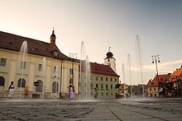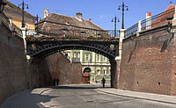
Grand Square Bridge of Lies

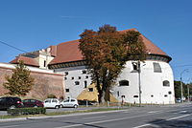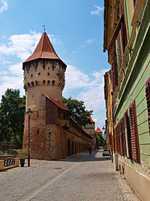
The Thick Tower Sibiu Fortifications

