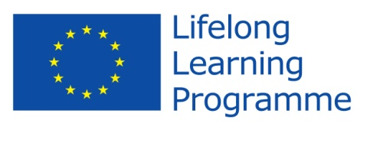
Comenius Project
United Europe - a perfect home to live in.
Initial Questionnaire for students

- Do you consider this project as
  - a teachers' project
  - a students' project 20 votes 100%
  - a school’s project
- Where did you learn about the programme?
  - from my teachers 6 votes 30%
  - from my friends 14 votes 70%
  - from Internet
- Do you think that your participation in the project will help you to increase your foreign language skills?
  - Yes 20 votes 100%
  - No
- Do you think the project is valuable in helping to improve attitudes towards people from different countries?
  - Yes 20 votes 100%
  - No
- Are you proud of being a member of the team?
  - Yes 20 votes 100%
  - No
- Can you name the rest of the countries which participate in the project with you?
LATVIA
SWEDEN
POLAND
BULGARIA
- Name two facts about the participating countries. What comes to your mind when mentioned of those participating countries?
4 COUNTRIES – HAD COMMUNIST REGIM
SWEDEN + LATVIA – COLDER THAN ROMANIA
SWEDEN IS A SCANDINAVIAN COUNTRY
I WAS IN STOCKHOLM ONCE
BULGARIA IS OUR NEIGHBOUR
POLAND – MY FRIEND CAROLINA LIVE THERE
SWEDEN – SNOW + GREAT LANDSCAPES
POLAND – MY MOTHER WENT THERE
BULGARIA – WARMER THAN ROMANIA (SOUTHERN COUNTRY)
PROJECT – A GOOD OPPORTUNITY TO CHANGE MY OPINION ABOUT THE WORLD
- Can you name the participating countries with their capital cities?
BULGARIA – SOFIA
SWEDEN – STOCKHOLM
POLAND – WARSAW
LATVIA - RIGA
- Try to find 3 similarities between you and your project partners.
SAME STUDENTS AGE
WANT TO LEARN MORE ENGLISH
SIMILAR DREAMS
MAKE NEW FRIENDS
WE ALL LIKE EATING, SLEEPING AND HAVING FUN
WE ARE ALL VERY EXCITED ABOUT KNOWING EACHOTHER
WE WANT TO COMMUNICATE IN ENGLISH
WE LIKE TO BE INVOLVED IN A PROJECT
- What do you expect from this project? Express your opinions shortly.
SPEAKING ENGLISH MORE FLUENTLY
KNOWING OTHER PARTNERS TRADITIONS
A BETTER LIFE EXPERIENCE
LEARN A LOT OF NEW THINGS ABOUT PARTNER COUNTRIES
STUDY THE CULTURE OF PARTNER COUNTRIES
I WANT TO SEE HOW STUDENTS FROM OTHER COUNTRIES LEARN
HAVE A NICE TIME
MAKING NEW FRIENDS
KNOWING NEW PLACES AND NEW PEOPLE

Thank you!

