NR 1 2013/2014 NUDY Z BUDY

School Magazine

,,United Europe – a perfect Home to live in,, News

All good things coming to an end.

Comenius project that lasted for two years coming to an end. Both students and teachers prepared reflections about the project below.

Thanks to Comenius project I have learned so much. I’ve made new friendships and I’ve visited many countries. Every partner had an opportunity to travel abroad to get to know another culture and customs. Polish team has created many art works , we also cooked and prepared Comenius Gala Days. We saw Swedish, Romanian , Latvian and Bulgarian art works and we loved them. What I loved the most was making e-cards and sending to different countries and meeting on skype from time to time. I’ve been learning about partnership countries and partnership countries been learning about my culture and my homeland – Poland. I enjoyed Comenius and l will miss my friends and these days.

Bulgaria

17th of April 2013 I went to Bulgaria to Sliven. I lived at Kolyo’s house for 7 seven days.

I visited primary school and I visited Kolyo’s school too. I was impressed by the friendly colleques. I took part in sport activities I saw welcome ceremony I saw sea I saw a beautiful place called Mount Blue . The food was totally different than Polish food. I think the language is difficult and different than mine.

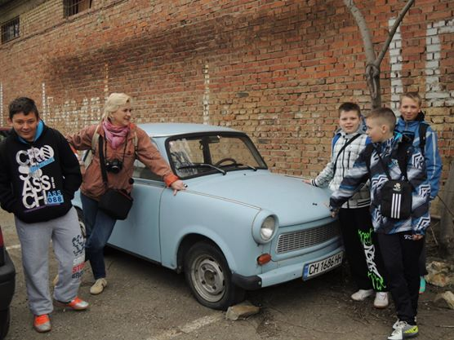

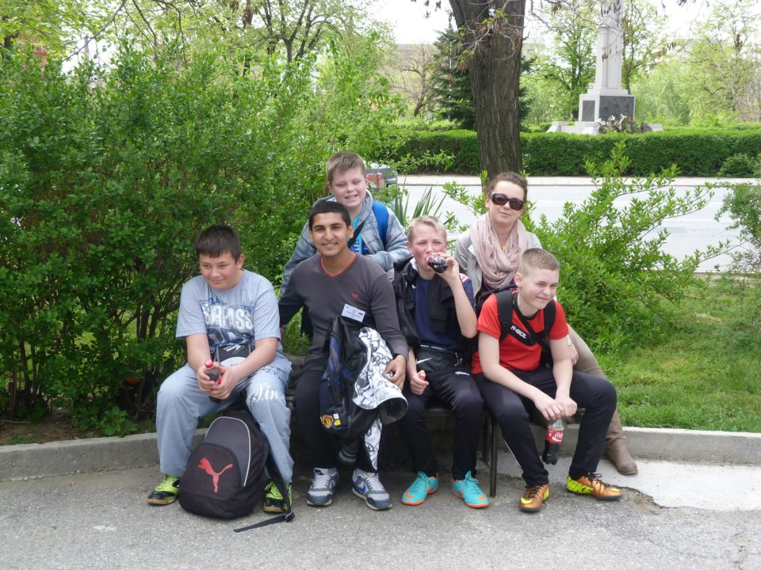

Comenius project gave me opportunity to make international friendships. I travelled to different countries and I got to know their culture , customs and environment people live in. I created also many works of art. I got to know new English words and I improved my English as well. I saw the houses people from different countries live in and I got to know their customs. I made e-cards exchange before festivals. I got to know how people celebrate their festivals. I prepared cooking book with recipes . I got to know basic vocabulary in four languages. These 5 countries are extremely different , but some words are similar or are pronounced similar. I enjoyed Comenius project and when it comes to an end I am sad because I will never see these people I made friendship with. I hope we will keep in touch.

My trip to Sweden

I went to Sweden in April 2014. At first we travelled to Lyckeskolan to meet families at school. Then we went to host families and teachers went to the hotel in Kinna. We got to know our host families. The food I tasted was delicious quite similar to Polish food. I visited schools , the lessons was very short , I think shorter than in Poland. I noticed many differences between Polish and Swedish educational system . I spent my free time with host family I had many sport activities , I went to swimming pool , shooting center , we had a barbecue , I visited also shopping mall. I like Swedish style.

I would like to visit Sweden again.

Mariusz

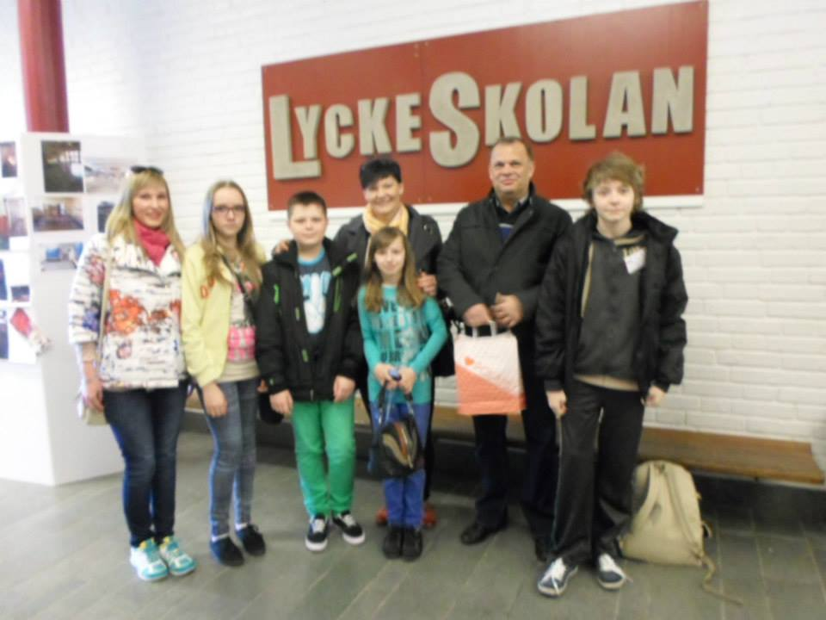

I joined Comenius project in September 2013 when I started my work as a teacher in school in Kronowo. I’ve never took part in such a project so it was a great opportunity to develop my skills. I visited Bulgaria in January 2014 with my headmaster and headmistress, we got to know Bulgarian language and culture. We compared educational system with Polish one. We found out that they are quite similar. We visited beautiful places and we were surrounded by friendly international teachers. Participation in this project gave us a new point of view on other cultures and countries. We found out interesting facts about Bulgarian and Swedish culture. In April we travelled to Sweden. We took part in welcome ceremony both in Sweden and Bulgaria. Teachers and students were involved in sport activities such as swimming or walking around countryside. Host coordinators looked after us and they were helpful in any condition at any time. A very important point during our staying abroad was to know educational system. We managed to lead long conversations with teachers from all partnership countries. We found out many ideas how to decorate our classrooms, how organize our lessons as well. Prospect of visiting another countries was a great opportunity to develop our skills and to exchange our experience with other teachers.

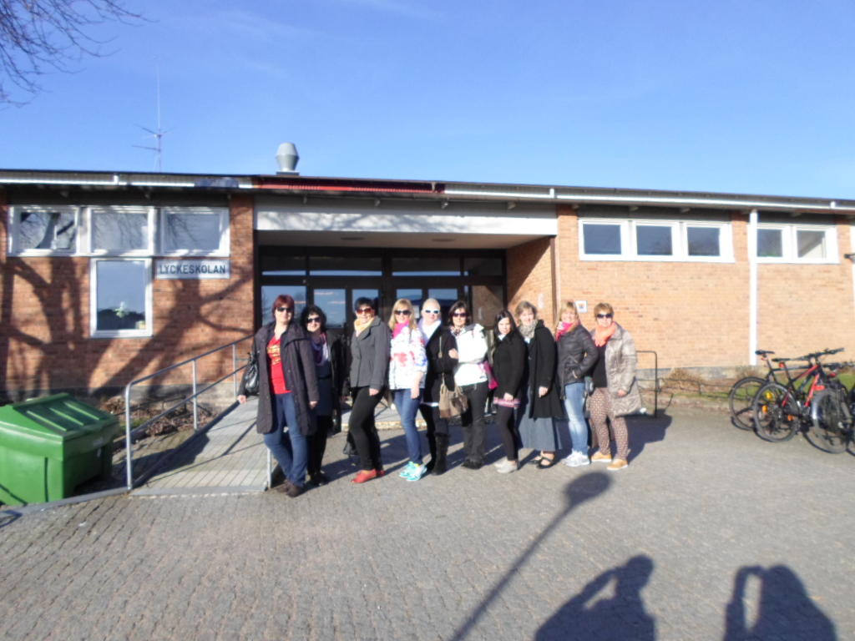Best teachers ever!

Life's a journey not a destination