**Salina Turda**

**Salina Turda is a**[**salt mine**](http://en.wikipedia.org/wiki/Salt_mine)**situated in [Turda](http://en.wikipedia.org/wiki/Turda" \o "Turda),**[**Transylvania**](http://en.wikipedia.org/wiki/Transylvania)**,**[**Romania**](http://en.wikipedia.org/wiki/Romania)**.**

**Since opening in 1992 until today, Salina Turda was visited by about 2 million Romanian and foreign tourists.**

**History**

**Salt was first extracted here during the**[**antiquity**](http://en.wikipedia.org/wiki/Classical_Antiquity)**and the mine continuously produced**[**table salt**](http://en.wikipedia.org/wiki/Table_salt)**from the**[**Middle Ages**](http://en.wikipedia.org/wiki/Middle_Ages)**(the mine being first mentioned in 1075) to the early 20th century (1932).**

**Since 1992, Salina Turda has been a [halotherapy](http://en.wikipedia.org/wiki/Halotherapy" \o "Halotherapy) center and a popular tourist attraction.**

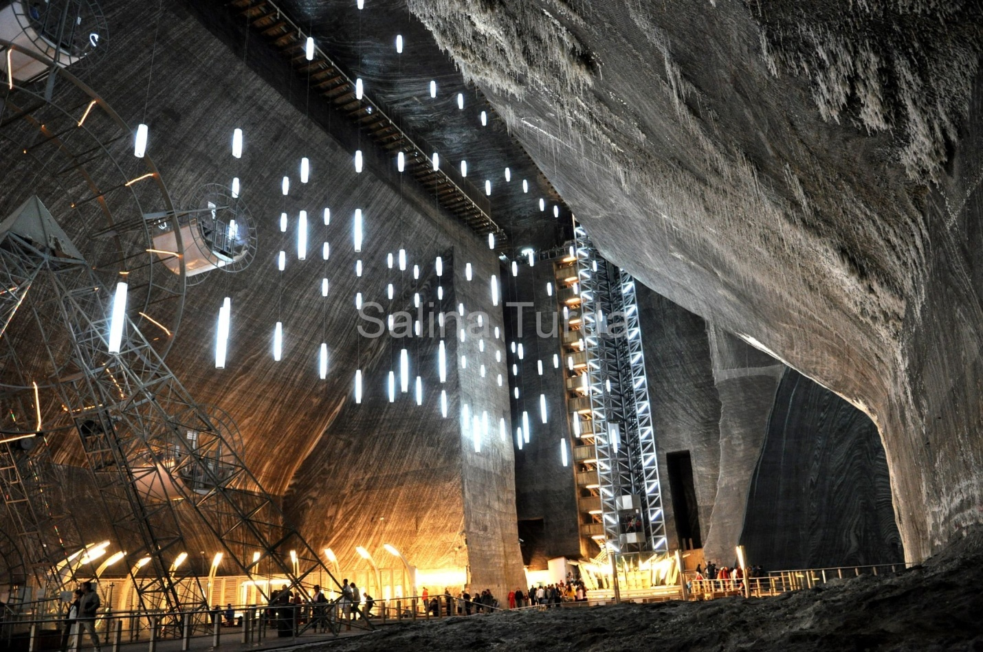

**A real museum of salt mining in Transylvania**

**The salt mine in Turda is now a veritable history museum of salt mining. The excellent state of preservation of mining and machinery used to transport salt, together with the cautious work carried out for prepararing the mine to become a tourist attraction, have made history and legend meet harmoniously here. The increasing number of tourists arriving from distant geographical areas to visit the mine are a confirmation of interest and historical value.**

**The Salt Mine is certainly the most famous destination for tourists visiting the town of Turda. This mine dating from the seventeenth century had a decisive factor in the development of his prosperous town from Roman times until today.**

**The clean recreational lakes and Durgau-mineralized waterare located near the Salt Valley, North of Turda. The five lakes were formed by water filling up former collapsed salt mines.**

**With a long tradition, during the summer, the Durgau lakesformed mineralized salt on old mining sites, offers tourists a wonderful place for recreation and relaxation in a natural setting. For convenience of tourists were sunbathing spaces, sand, wooden pontoons, showers and a bar terrace.**

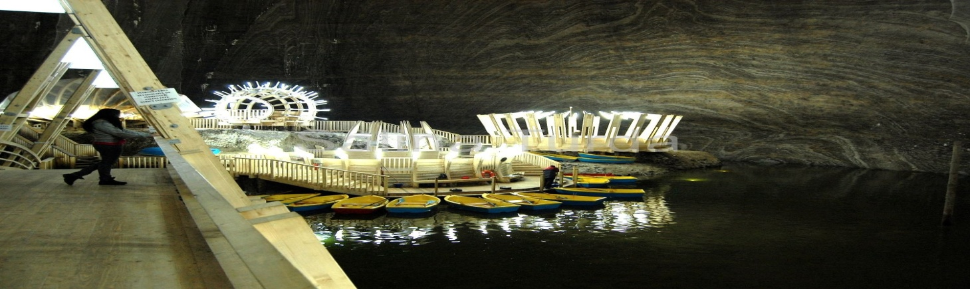

**Lakes**

**The clean recreational lakes and Durgau-mineralized waterare located near the Salt Valley, North of Turda. The five lakes were formed by water filling up former collapsed salt mines.**

**With a long tradition, during the summer, the Durgau lakesformed mineralized salt on old mining sites, offers tourists a wonderful place for recreation and relaxation in a natural setting. For convenience of tourists were sunbathing spaces, sand, wooden pontoons, showers and a bar terrace**.

