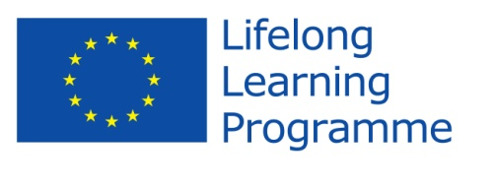
Comenius Project
United Europe - a perfect home to live in.
Initial Questionnaire for students

- Do you consider this project as
  - a teachers' project
  - a students' project 75%
  - a school’s project 25%
- Where did you learn about the programme?
  - from my teachers 100%
  - from my friends
  - from Internet
- Do you think that your participation in the project will help you to increase your foreign language skills?
  - Yes 100%
  - No
- Do you think the project is valuable in helping to improve attitudes towards people from different countries?
  - Yes 100%
  - No
- Are you proud of being a member of the team?
  - Yes 100 %
  - No
- Can you name the rest of the countries which participate in the project with you?
ROMANIA
POLAND
LATVIA
BULGARIA
- Name two facts about the participating countries. What comes to your mind when mentioned of those participating countries?
ROMANIA- The country is shaped like a fish. Malin was there.

POLAND –Common history with Sweden. Polish workers in Sweden.
BULGARIA – A warm country. The Black Sea.
LATVIA – Lots of forests. Cold.
- Can you name the participating countries with their capital cities?
ROMANIA - BUCAREST
SWEDEN - STOCKHOLM
POLAND - WARSAW
LATVIA - RIGA
- Try to find 3 similarities between you and your project partners.
WE WISH TO IMPROVE OUR ENGLISH.
WE ARE ALL TEENAGERS.
WE WANT TO KNOW MORE ABOUT EUROPEAN LIFE.
- What do you expect from this project? Express your opinions shortly.
We want to learn more about the participating countries , learn a little about the different languages. Get to know people in other countries. Be able to practise English. Make life-time friends.
Thank you!

