

**COMENIUS 2012 – 2014**

**UNITED EUROPE – A PERFECT HOME TO LIVE IN**

**CHRISTMAS AND NEW YEAR’S EVE TRADITIONAL RECIPES**

**Romania**

**Poland**

**Bulgaria**

**Sweden**

**Latvia**



# TRADITIONAL CHRISTMAS AND NEW YEAR’S EVE

DISHES FROM ROMANIA

# Meat balls in cabbage

*Ingredients:*

1,5-2 kg of pork meat

2-3 onions

1 cup of rice

green parsley

1 spoon of tomato sauce

1 spoon of oil

½ a glass of tomato juice

cabbage leaves

salt and spices as you like

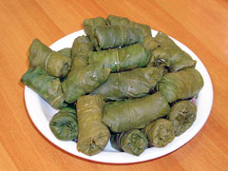

*Preparation:*

Chop the pork meat. Chop the onion and boil it for a few minutes, then drain it from water and put it with the meat. Add the rice, parsley, tomato sauce, salt and all the other spices.

Take a small quantity of the mixture (use a spoon) and wrap it into a cabbage leaf and put them into a clay pot. On the last row of “stuffed cabbage” chop some cabbage and put it over the meat balls in cabbage. Pour hot water on them and set them on the cooker, at medium heat.

When they are almost boiled pour some oil and tomato juice on them, in the pot.

Honey Cookies

*Ingredients:*

1 glass of honey

3 eggs

200 grams of sugar

2 and ¾ glasses of flour

3 spoons of oil

1 packet of vanilla sugar

1 spoon of cinnamon

1 packet of clove powder

1 citron (lemon peel)

Butter for buttering the tray

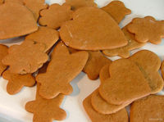

*Preparation:*

Mix the honey with sugar in a small pot at low heat on the cooker till they melt. Take them from the cooker and add an egg, in turn, a spoon of oil, in turn, and a little flour till they all finish. Add cinnamon, vanilla sugar, clove powder and the citron. After they are all mixed, tear small pieces of dough and model different shapes (snowmen, fir-trees, etc) and put them in a buttered and floured tray. Cook them in the oven at a medium heat.

# Moldavian Cake “Cozonac”

|  |  |
| --- | --- |
| *Ingredients for dough:*  5 kilos of flour  250-350 grams of fresh yeast  30 yolks  1 kilo of sugar  2,5 liters of milk  2 packets of margarine  500 ml of oil  100 grams of raisins  1 small bottle of rum essence  1 citron  5 teaspoons of salt | *Ingredients for filling:*  1 kilo of walnuts;  10 egg whites  50 grams of cocoa  500 grams of sugar  1/3 packets of margarine  2 eggs  4-5 spoons of milk  2-3 spoons of flour  200 grams of raisins soaked in rum |

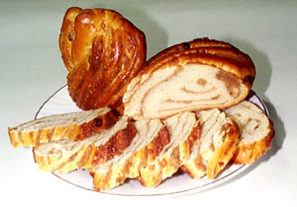

*Preparation:*

Soak the yeast in mild water, put a few spoons of flour and let them ferment.

Separately pour hot milk on 10 spoons of flour, mix it very well and let them cool.

After the yeast fermented till it doubled its volume mix it with the hot flour (cold now) and let them ferment again. Separate the eggs (the egg-whites from yolks) and mix the yolks with salt. Heat the milk and mix it with the sugar, citron and rum essence until the sugar melts. On top of the flour from bowl put the yolks, yeast and milk, little by little, until they are all mixed well together. Knead the dough very well adding the oil and melted margarine little by little; at the end add the raisins. It is ready when it gets off hands. Let the dough to ferment for about 50-60 minutes. Meanwhile prepare the filling.

*Cocoa filling*: Mix the cocoa with the flour, margarine, 200 grams of sugar, eggs and milk until it becomes a thick cream.

*Nut filling*: Mix grinded nut with 10 whipped egg-whites and 300 grams of sugar.

After the dough has fermented, split it in 10 parts (for 10 cakes). Take one piece of dough, split it in two and roll it on into 2 layers. On one of them put the nut filling, on the other one put the cocoa filling. On top of them you can spread raisins. Roll each layer and then knit the two together into one cake which it will be set into the tray. Heat the oven before putting the tray into it.

**Pork Aspic**

# *Ingredients:*

3-4 pork legs

1-2 pork ears

6-7 cloves of garlic

1 carrot

1 parsley (root)

1 tie of parsley leaves

Salt, pepper

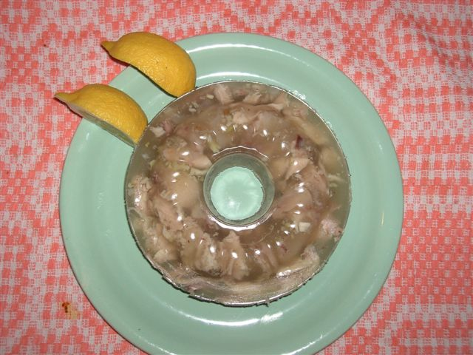

*Preparation:*

Wash (very well) pork legs and ear, and then put them to boil into water. The water should cover them with more than 5 centimeters. Put salt and let them boil for 3 hours, take the foam from time to time. Peel the carrot and parsley then add them into the boiling water and let them boil for an hour. When they are all boiled, take out the meat and the vegetables, filter the soup. Meanwhile peel the garlic, and smash it, then add it into the filtered water. Take the meat off the bones and put it into bowls together with the carrot cut in pieces and 1-2 leaves of parsley. Cover them with soup and put them in a cold place so that the soup becomes a jelly.

# Meat Balls Soup

*Ingredients:*

500 grams of minced meat

2 onions

150 grams of rice

2 eggs

2 carrots

1 parsley root

parsley leaves

200 grams of sour cream

1 lemon

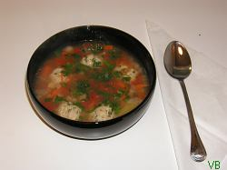

*Preparation:*

Mix the minced meat with one chopped onion, rice and beaten eggs. After they are all mixed well, make meatballs from this composition.

Put water to boil. Meanwhile peel and chop the carrots, one onion and the parsley root. When the water boils put the meat balls in it and, then the chopped vegetables. When they are all boiled, before taking it off the cooker add the juice from lemon, the sour cream and the parsley leaves.

# Moldavian Cheese Cake

*Ingredients:*

1 kilo of flour

4 eggs

300 ml milk

100 grams butter

100 ml oil

60 grams yeast

200 grams sugar

200 grams sweet cheese

200 grams sheep cheese,

1 teaspoon salt

flavors

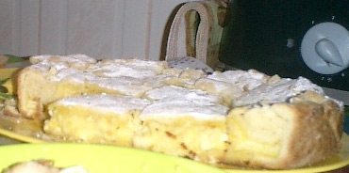

*Preparation:*

Mix some mild milk with yeast, 2 spoons of sugar, 5-6 spoons of flour. Let them ferment for about 30 minutes in a hot place. Put all the ingredients over the fermented composition, except from milk, butter and oil. Mix everything and, if needed, add some more milk (it depend how soft the sweet cheese is). At the end add butter mixed with oil and knead the dough until it gets off hands.

Roll the dough and then cut it into small pieces which will become small pieces of cake.

You can put pieces of paper with messages into these pieces of cake, before they are put in the buttered tray. Pour beaten eggs, sugar and put them into oven for about 30-40 minutes.

# TRADITIONAL CHRISTMAS AND NEW YEAR’S EVE

DISHES FROM POLAND

**Barszcz czerwony - Red borsch**

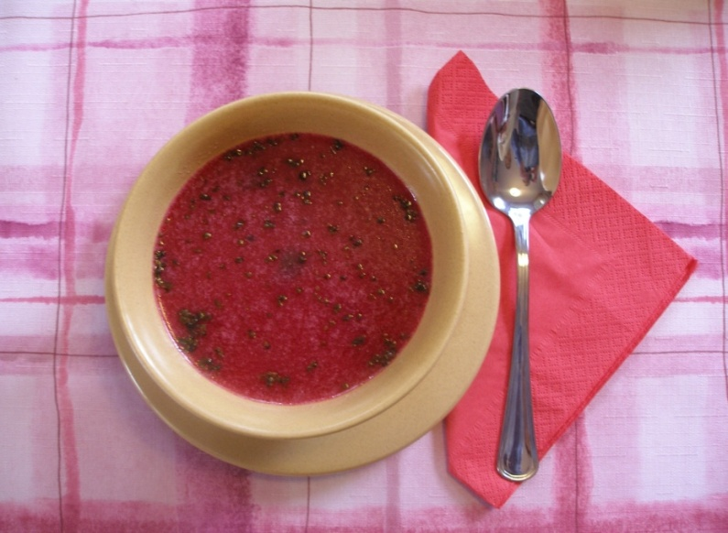

**Ingredients:**

* 1,5kg of red beetroots,
* apple,
* 2-4 cloves of garlic,
* laurel leaf,
* 3 grains pimento,
* salt,
* pepper,
* marjoram,
* sugar to taste,
* vegetable brew,
* 4-5 dry mushrooms,

**How to make it**

* Firstly boil red beets in skin till they will be soft ( look out! They can’t overboil!).
* Secondly peel them, rub against grate with big holes and put to big pot.
* Add garlic, segments of sour apple, laurel leaf and pimento.
* Next flood everything with vegetable brew and heat it slightly.
* At the end put salt, pepper, sugar to taste and even put lemon juice to taste if you like. The same with marjoram if you like it you can use it.
* Serve it with ravioli, patties. Good appetite!

**Pierogi z kapustą i grzybami - Ravioli with cabbage and mushrooms**

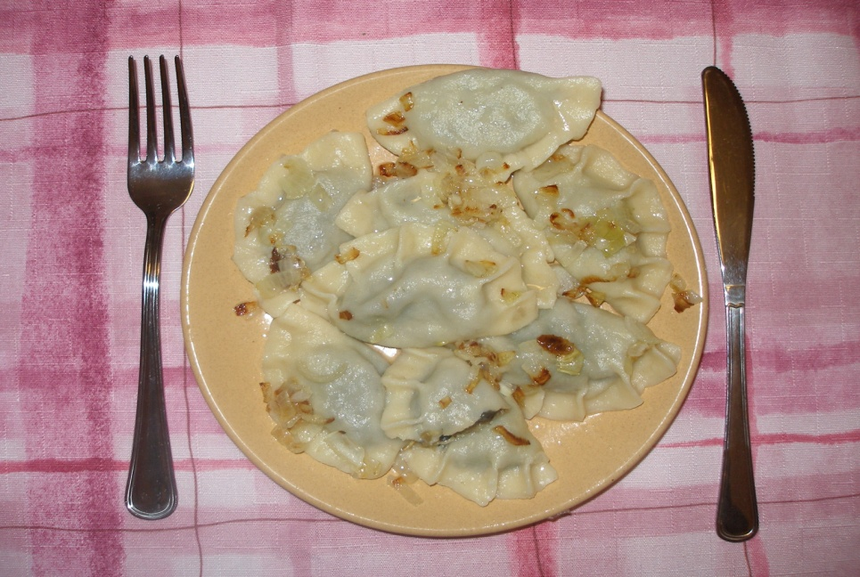

**Ingredients:**

|  |  |
| --- | --- |
| ***Batter:***   * 0,5kg wheat flour, * 1 glass of water, * vitellus, * 1 tea-spoonful of butter, * Salt, | ***Stuffing:***   * 0,5kg sauerkraut, * 10dag dry mushrooms, * salt, * pepper, * oil, |

**How to make it**

* If the sauerkraut is very sour , squeeze it slightly, put to pot, pour water and add oil and boil it.
* Mushrooms put to a small bowl with water (for 8 hours) and later boil.
* Squeeze sauerkraut from water and cut into tiny bits, make the same with mushrooms. Put everything to a deep bowl, mixed with few table-spoonful of oil and add salt and pepper.
* All components for batter mix together and make for one stretchy mass.
* After pining batter, cut roundlets, put on each one stuffing and stick them.
* Put them to boiling water with salt and oil till they emerge over water.
* They are tasty when you pour butter over them or fry on frying pan.

**Bigos: król polskich potraw - The kig of Polish dishes: Bigos**

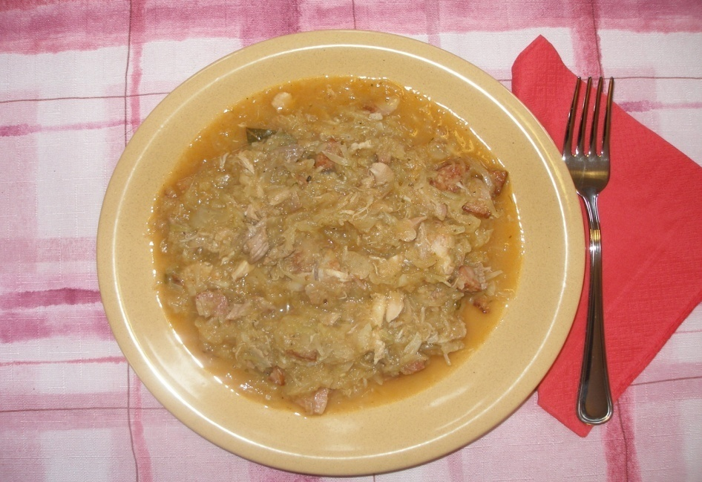

**Ingredients:**

* cut cabbage and sauerkraut,
* vegetable broth,
* meat: sausage, belly, ham ( it should be 30% of meat using in bigos),
* venison,
* baked and boiled meat (pork, beef),
* fat poultry ( duck’s and goose’s meat),
* smoked bones (to broth),
* back fat ( to fry with meat),
* spices: pimento, laurel leaf, pepper in grains, caraway, juniper, thyme, marjoram,
* onion,
* dry mushrooms,
* dry plums
* We start our bigos with broth in which we can put brew of smoked bones.
* Cut sauerkraut and cabbage as many as you want and add to broth . We add meat in this order: baked, boiled and at the end beef meat. But earlier fry them on frying pan with back fat and cut onion.
* Add to it spices and dry but cut and boil mushrooms. Brew after mushrooms leave to use at the end.
* Next add dry plums which few minutes earlier put to water to make them soft.
* Salt everything but don’t use a lot of salt because meat have some salt in it. At the end of stewing add fresh grind pepper

# TRADITIONAL CHRISTMAS AND NEW YEAR’S EVE

DISHES FROM BULGARIA

**MUSAKA**

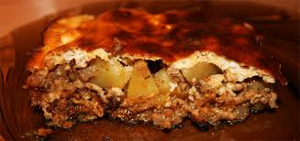 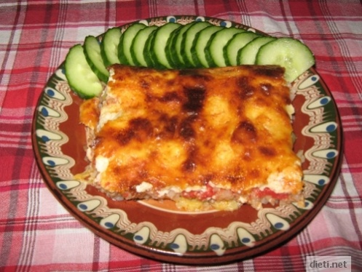

**INGREDIENTS:**  
 1 onion  
 500 g minced meat   
 1.5 - 2 kg potatoes  
 50 ml oil  
 **spices:**  
 salt, pepper and paprika  
 1 bunch of parsley  
 **topping:**  
 1 cup yogurt  
 4 eggs

4 tablespoons flour  
 salt

**DO THIS :**

Peel and dice the potatoes, salt and pour 1tea cup of hot water. Boil them

until soft.  
 Cut the onion and sauté in 1coffee cup of oil.  
 Add the minced meat and mashing until crumbs. Next add the black pepper and

paprika. Let fire for 5-10 min. Before removing from the heat add the chopped

parsley. Mix with the potatoes. Pour into baking dish.

Products for the dressing beat well, pour over the dish and turn the upper

wire or grill if your oven has one. Pour over. It’s ready when you acquire gold

crust.

Serve with salad or yogurt.

**STUFFED PEPPERS WITH MINCED MEAT AND RICE**

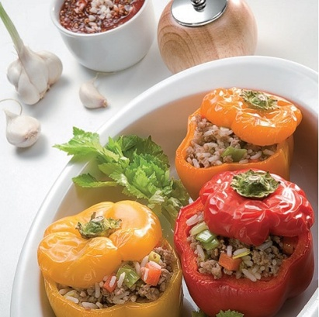 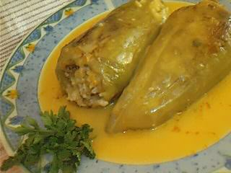 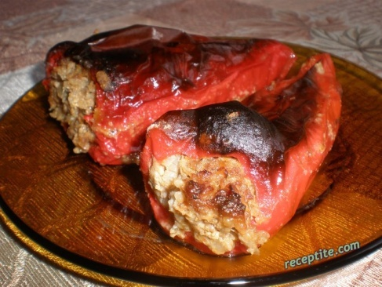

|  |
| --- |
| **INGREDIENTS:**  10 peppers  1 onion  1 carrot  500g minced meat   1 cup of rice  1 egg  1 cup yogurt  oil, flour  **Spices:**  paprika, savory, black pepper, salt, fresh parsley |
| DO THIS : Onions and carrots are chopped and stewed with a little oil and water.  Add the minced meat, fuzzy with a little water and stew it at about 15 minutes.  Insert the washed rice, spices and pour 1 cup of water. Suffocates while  rice is semi, stirring to prevent sticking to the bottom of the pan.  The peppers are cleaned from the stems and seeds, riddled with needle in several  places and fill with mixture. Arrange them in a deep dish.  Pour salted water to half (if you want a thick sauce is added  diluted flour), sprinkle with oil and put in preheated oven. Bake approximately 30  to 40 minutes, then remove the tray.    DRESSING : Separate into a bowl 1-2 ladles of the sauce to cool for 10 minutes.  Crash the egg with the yogurt and salt and while breaking it pour the cooled  sauce. The resulting mixture is poured into the tray with peppers and gently  shake to distribute. |

**STUFFED PEPPERS WITH BEANS**

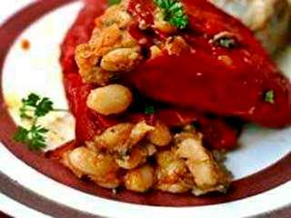 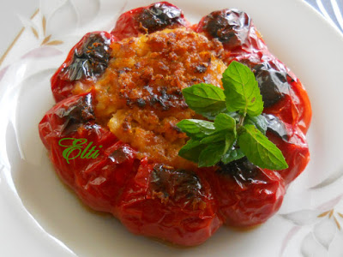

## INGREDIENTS: 100 g peppers 1 cup beans 1 onion 50 ml cooking oil spices: 1 tablespoon paprika 1 teaspoon mint 1 teaspoon savory

**DO THIS:**   
  
Boil the beans in full mode.  
Chop the onion into small cubes and stew until soft. Once browned, add paprika to it. A minute later put the cooked beans, savory and the mint.  
Remove the filling from the heat. Stuff the peppers with the beans.  
Then arrange them in a baking dish, pour a little oil and water are place in a moderate oven for no more than 30 minutes.

**BIRD'S NEST**

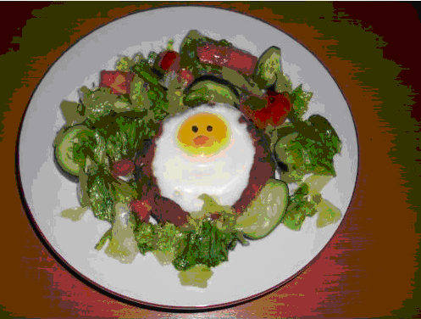 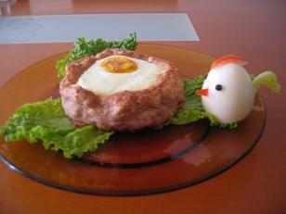 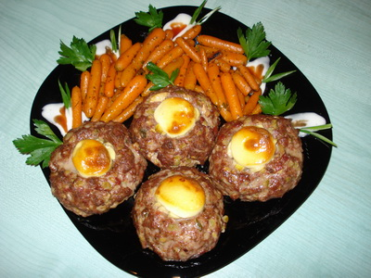 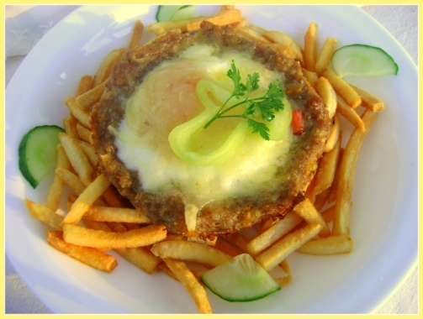

**INGREDIENTS:**  
vegetables for the filling:  
100g mushrooms, 100g corn, 100g peas, 1 carrot  
**for the nests:**  
500 g minced meat   
1 onion  
1 egg  
1 slice of dry / older / bread or toast  
**spices:** pepper, paprika, savory, mustard, salt - if necessary  
some milk  
5 eggs - the number depends on the number of the nests that will be shaped.  
100g yellow cheese for grating  
oil - for greasing the tray

**НАЧИН НА ПРИГОТВЯНЕ:**

1. Sauté mushrooms, corn and peas.

2. Cut the onion into small pieces or grate it on a grater. Grind the bread until crumbs. Add them to the minced meat.  
Add to the mixture 1 egg, spices and some milk until the mixture is soft. Knead the mixture well.  
Make 5 big balls from the mince meat / 100g / and put them at a distance in a covered with a baking sheet / or oiled / tray, then shape them as nests /make a hole/, so that even shrink during baking , still has room for the vegetables and the egg.  
Bake them in a hot oven / 200˚C / and only a few minutes before their official withdrawal in each of the holes grate yellow cheese add the vegetable mixture and 1 egg. Continue cooking until the eggs ready.  
Remove them and serve with a garnish or salad of your choice.

**CHRISTMAS CAKE**

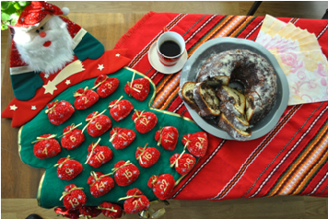

**INGREDIENTS:**

4 eggs,

1.5 cups granulated sugar,

2.5 cups flour,

1 baking powder, 1 vanilla  
50g chopped walnuts

50g raisins

50g orange and lemon peel,

2 tablespoons cocoa

1 cup incomplete oil

1 cup incomplete water or milk

**DO THIS:**

Beat the eggs together with the granulated sugar until turn white, then add a trickle of olive oil while continuing beating the mixture with a mixer. Add water then the flour in which you have added baking powder and vanilla and beat with a mixer again, but not at full speed.  
Then pour in a tea cup 2 tablespoons cocoa and top with the prepared cake mixture.  
Mix very well with a spoon. Pour 2/3 of the remaining mixture in the greased cake pan. Pour cocoa mixture on the top and sprinkle on her nuts, raisins, orange and lemon peel. Pot up a fork and start doing spiral circles around the mixture, then pour the remaining 1/3 of the mixture.  
Bake on the lower wire at temperature t = 250˚C until the form is filled, then  
turn the upper and lower wire, or just the upper one / depends on oven /.  
While hot sprinkle with powdered sugar.

# TRADITIONAL CHRISTMAS AND NEW YEAR’S EVE

DISHES FROM SWEDEN

Swedish recipe of toffee ( Knäck )



Ingredients

75 pcs

2 cups whipping cream

2 cups syrup

1 cup blanched, chopped almonds

2 tablespoons breadcrumbs

2 tablespoons butter

Toffee molds

Do this:

Mix the cream, syrup and sugar in a heavy saucepan.

Cook uncovered, stirring occasionally until the mixture is capable of breaking. Check this by using ”the ball test”, or until the interal temperature is 122 degrees, about 15-30 minutes. Add the chopped almonds, bread crumbs and butter.

Spread the batter into the molds. Allow to set. Store in refrigerator.

”The ball test”:

Poor a few drops of the mixture into ice-cold water and roll into a ball. The ball should be firm to hard.

Linnea and Stina.

***Rice porridge***

(to eat on it’s own or use in the Ris á la Malta)

1 tablespoon butter

2 dl round grain rice  
½ tsp salt

4 dl water  
7,5 dl milk  
1 cinnamon stick

Melt the butter in a saucepan. Add rice, salt and water. Bring to a boil while stirring.Reduce heat and boil slowly for 10 minutes. Add the milk and cinnamon stick. Let the porridge cook over very low heat about 40 minutes. Stir occasionally. Take care so that the porridge does not boil over. Serve the porridge with milk, a little sugar and ground cinnamon and possibly a dab of butter.

[](http://www.google.se/imgres?q=risgrynsgr%C3%B6t&num=10&hl=sv&sa=X&biw=1366&bih=585&tbm=isch&tbnid=WeoVMOU_m3czkM:&imgrefurl=https://www.coop.se/Recept--mat/Recept/r/risgrynsgroet-i-olika-portioner/&docid=ALbR4jqw91cdsM&imgurl=https://www.coop.se/EPiServerCommunity/Modules/ImageGallery/Thumbnails/94/2194/18318_64044.jpg&w=400&h=400&ei=7DeqUMSEE6jx4QToqID4Cw&zoom=1&iact=hc&vpx=823&vpy=155&dur=484&hovh=225&hovw=225&tx=159&ty=128&sig=103506116019473449390&page=1&tbnh=109&tbnw=109&start=0&ndsp=22&ved=1t:429,r:5,s:0,i:122)

Lussekatter (saffron buns)

35 pieces

Ingredients:  
  
50 g yeast  
100 g Butter   
1 liter milk  
250 g quark (optional)  
2 sachets of saffron, about 1 g (optional)  
1.5 dl sugar  
1/2 teaspoon salt  
approx 17 dl flour  
raisins  
1 egg

Do this:

Preheat the oven to 225 degrees.

Crumble the yeast in a dough bowl. Melt the butter in a saucepan. Add milk and heat to luke warm, about 37 °. Pour the milk and butter over the yeast. Stir to dissolve the yeast. Add the quark, saffron, sugar, salt and most of the flour. Work the dough until it becomes smooth and shiny and releases from the edges of the bowl. Add more flour if necessary. Let rise covered for about 30 minutes. Bake the dough for saffron buns, shape them into an S. Place them on greased sheets. Garnish with raisins. Let rise for 20-30 minutes. Brush with beaten egg. Bake in middle of oven 5-7 minutes. Let cool on a rack under a kitchen towel.

PS: You can skip the raisins.

Elin and Benjamin



**Ris á la Malta**

Serves 4

+



Ingredients:

1.5 dl whipping cream

3 dl cold rice porridge

1 tablespoon powdered sugar

1 teaspoon of vanilla sugar/essence

2 oranges

Do this:

Whip the cream and mix with porridge, powdered sugar and vanilla essence. Peel and slice the oranges in pieces, mix with rice. Enjoy!

**Pepparkakor (Gingerbread cookies)**

Makes 100 cookies

Ingredients:  
  
175 g butter, unsalted  
1 ½ dl syrup  
2 ½ dl brown sugar  
1 teaspoon ground cloves  
1 teaspoon ground ginger  
2 tsp ground cinnamon  
2 teaspoons minced orange peel  
1 ½ dl heavy cream  
10-11 dl flour  
2 tsp bicarbonate of soda

Do this  
Mix butter, syrup, sugar and spices in a bowl or food processor. Stir the cream into the spice mixture. Add the flour mixed with baking soda and work together to form a dough.  
**Let rest in refrigerator about one day**. Take out the dough 1 hour before baking. Preheat the oven to 225 ˚. Roll out the dough thinly on floured work surface and cut the cookies with cookie cutters or knife. Place them on baking trays with baking paper and bake in middle of oven about 5 minutes. Let the cookies cool on the sheet and then place 

# TRADITIONAL CHRISTMAS AND NEW YEAR’S EVE

DISHES FROM LATVIA

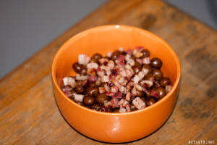**Grey peas with bacon**

Ingredients:

* 1 kg of gray peas,
* 500g smoked or unsmoked streaky bacon,
* 1 large onion,
* salt
* pepper,

Preparation:

The previous evening, soak peas so they cook more quickly. 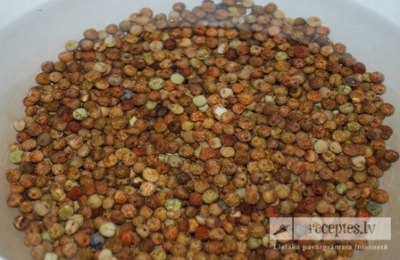 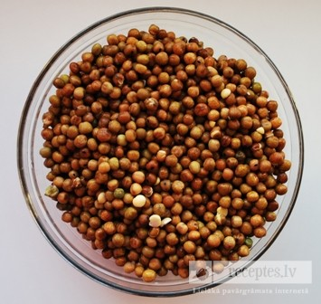

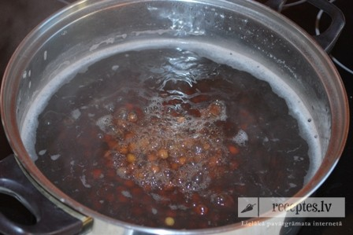 Put them in a pot with hot water to cover and boil for about 40 minutes. But from time to time to check whether there are already ready more quickly, depending on the size of peas and hardness. When the peas are already almost tender, add salt and boil for to the end.

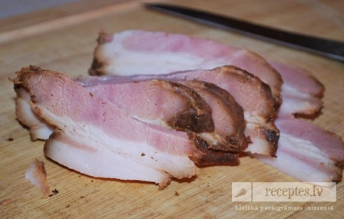 Meanwhile, around the cook dice onion and bacon into small cubes.

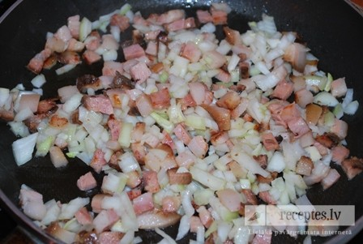 Put on the pan and bake. When the meat turns brown, cook on a slow fire in order to lard runs out more fat.

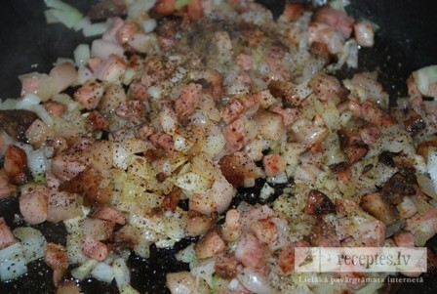 Add some pepper

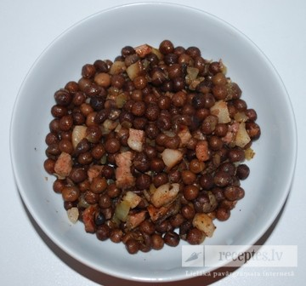 Serve drained peas in individual clay bowls, adding fried bacon mixture to each serving.

***Sweet Rye Trifle or Latvian Ambrosia***

* 300g dry, dark rye bread,
* 200g cranberry jam (raspberry, or other your favourite)
* 160g sugar,
* cinnamon,
* 250g sweet cream,
* fresh cranberries.

Finely grate the rye bread and mix with the cinnamon and half of the sugar.

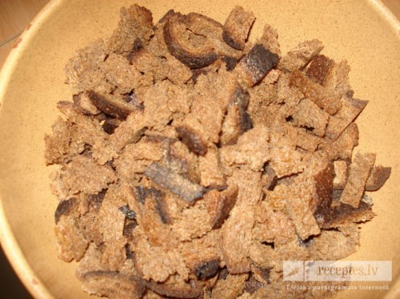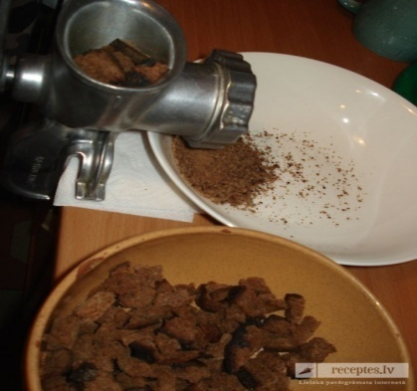

Whip the cream adding the sugar. Whip until you get stiff peaks.

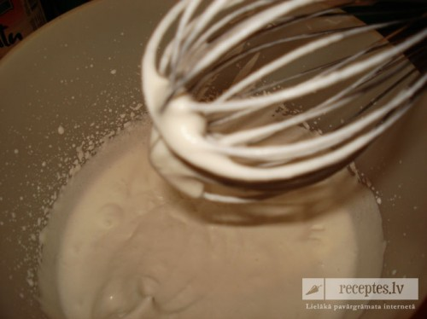

In a shallow dish (glass) arrange the ingredients in layers : the rye bread, then the jam, then whipped cream, then the rye bread again, etc.

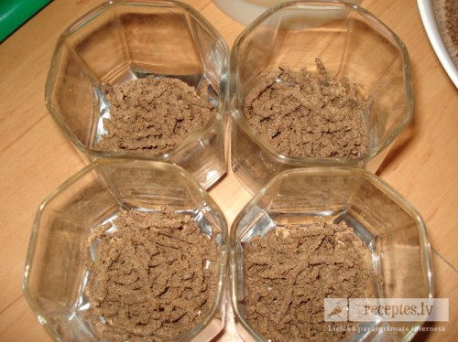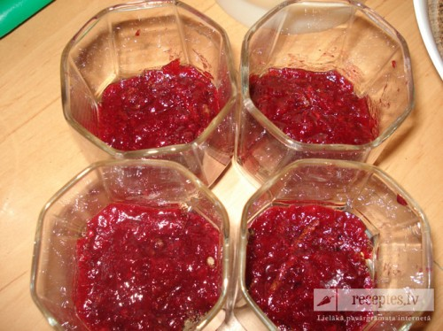

Making the bread the top layer. Decorate with wipped cream and cranbemies.

Leave it for 3 – 4 hours.

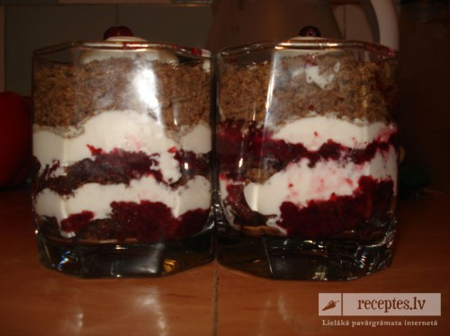

# *http://t1.gstatic.com/images?q=tbn:ANd9GcQ8hUFaJjzrH_TvdeIZ3SeT287AiNC_8bXTQYzxnJvlobG9CFe1SQLatvian Bacon Buns*

Ingredients:

Yeast dough : 0,5 l milk,

1 kg white flour,

50g yeast,

100g butter,

25g sugar,

salt

Filling: bacon, onion, black pepper Egg for spreading.

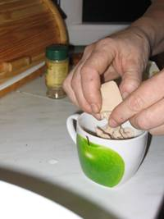 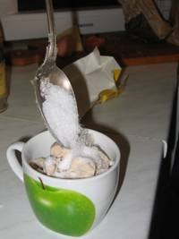 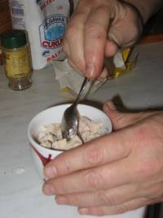 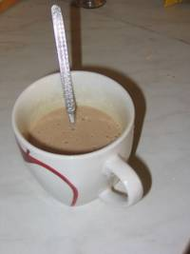

Add a teaspoon of sugar yeast, stir, add a drop of warm milk and put to rise.

Warm milk (about 30 C), poured half of the flour, add the yeast, add sugar, melted butter, a little salt, remaining flour and knead until the dough becomes shiny and dry, does not stick to your hands. Sprinkle with flour . Cover bowl with damp cloth, and let rise in a warm place until doubled in bulk (30 - 90 minutes, depending on the warmth of the environment).

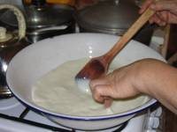 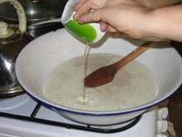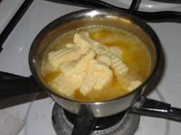

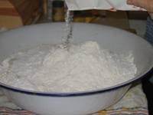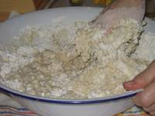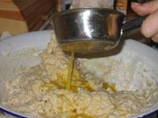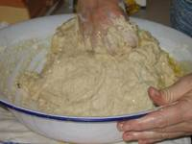

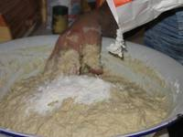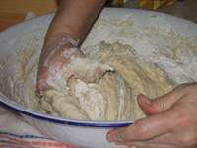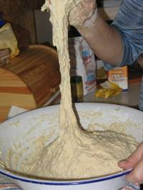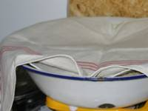

Cut bacon into small cubes and mix with pepper, salt and chopped onion.

When the dough has risen, punch it down. Preheat oven to 200° C. Prepare a floured surface for making the buns.

Cut off a large piece of the dough. Roll it into a rope about 4 cm in diameter. Cut it into segments about 4 cm thick. Make each bit into a small pancake, oval, or square. On one half of it, put a teaspoonful or a little less of the filling. Fold the dough over, pinching the edges together or use a small glass to press down the edges. Make sure there are no openings left, or the filling will leak out of the seam.Leave to rise for 5-10 minutes.

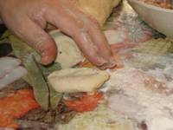 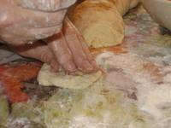 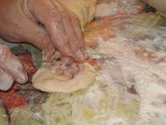

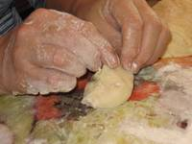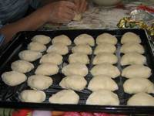

Brush with beaten egg and bake

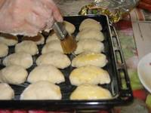

Bake at 200° C for 13 - 18 minutes, depending on their size, and how brown you want them to look. Golden brown is good.

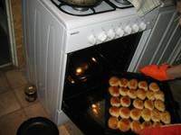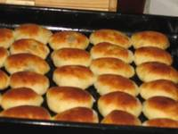

Enjoy your meal!