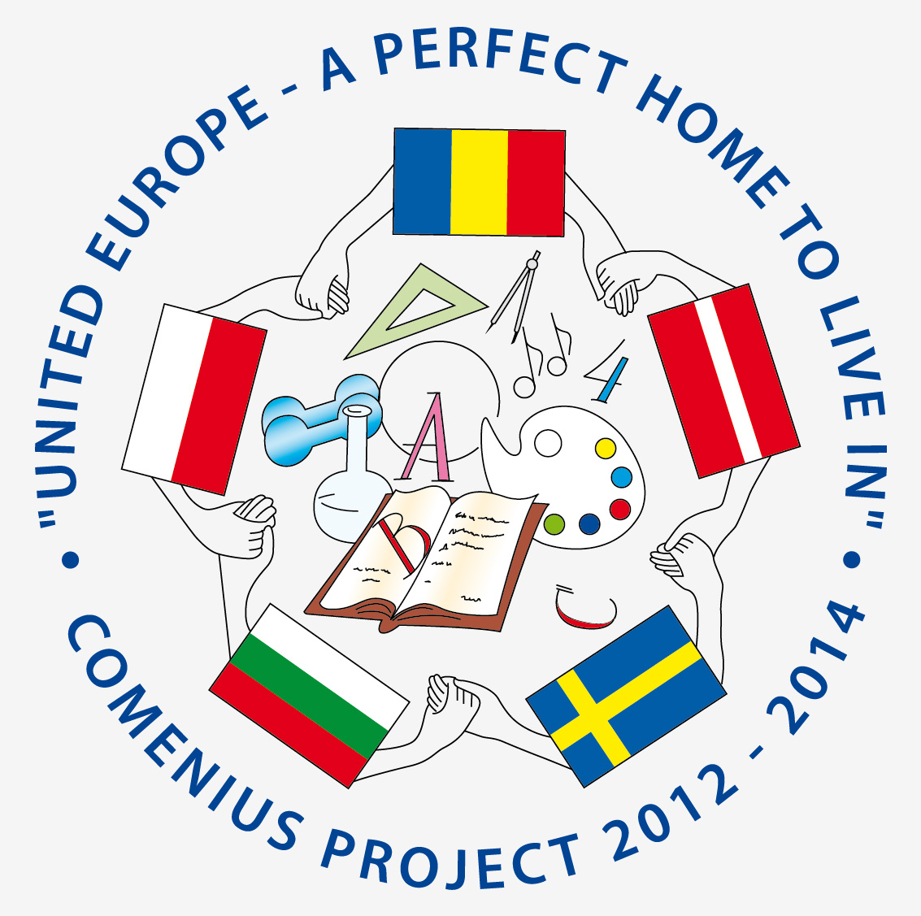
UNITED EUROPE - A PERFECT HOME TO LIVE IN
COMENIUS PROJECT 2012 - 2014
PROJECT MEETING SCHEDULE
SLIVEN, BULGARIA
17.04.2013 - 23.04.2013
FOR STUDENTS
17.04.2013
- ARRIVAL DAY
- ACCOMODATION
- EVENING FREE
18.04.2013
- 9.30 - WELCOME CEREMONY.
- 9.45 - 11.00 – PERFORMANCE OF BULGARIAN SPRING CUSTOMS BY STUDENTS. DISPLAYING PRESENTATIONS ABOUT BULGARIA, SLIVEN AND THE SCHOOL
- 11.00 - 12.30 – VISIT TO THE ART GALLERIES “SIRAK SKITNIK” / ORPHAN WANDERER / AND “DIMITAR DOBROVICH”
- 12.30 - 13.30 –LUNCH AT HOTEL KREDO
- 13.30 – 14.30 – REGIONAL INSPECTORATE OF EDUCATION, SLIVEN
- 14.30 - 15.30 – VISIT THE HISTORICAL MUSEUM
- 15.30 - 17.30 – BULGARIAN STUDENTS TELL ABOUT SIGHTSEEINGS OF SLIVEN.
- 18.00 – 19.00 DINNER
19.04.2013
- 8.00 – BREAKFAST
- 8.30-10.00- ACTIVITIES AT SCHOOL
- 10.00 - 11.00 - MEETING WITH THE MAYOR OF SLIVEN
- 11.00 - 12.30 – SPORT ACTIVITIES
- 12.30 - 13.30 – LUNCH
- 14.00-15.30- VISIT TO III PRIMARY SCHOOL
- 15.30- 17.00 – PLANTING OF TREES AND BUSHES
- 17.00- 18.00 – TOUR OF THE SCHOOL
- 18.00 – 19.00 DINNER
20.04.2013
TRIPS IN THE MOUNTAIN “KARANDILA” - Natural Park " Blue Stones"
- PICNIC
- SPORT ACTIVITIES
21.04.2013
- TRIP TO NESSEBAR, SUNNY BEACH AND BURGAS
- SIGHT – SEEINGS
- SPORT AN CULTURAL ACTIVITIES

22.04.2013
- 9.00 - 10.30 VISIT TO THE Museum of textile industry
- 10.30 - 12.00 - interesting and funny games – puzzle AND surpriseS…
- 12.30 - 13.30 - LUNCH
- 13.30 - 14.30 - VISIT TO THE MUSEUM OF EDUCATION IN SCIENSE MATHEMATIC SCHOOL
- 15.00 - 16.30 – TOGETHER TO LEARN LANGUAGES
- 17. 00 – 18.30 – VISIT SLIVEN WITH BULGARIAN STUDENTS
- 18.30 - DINNER

23.04.2013
- SAYING GOODBYE, IMPRESSIONS, KISSES AND HUGS
- DEPARTURE DAY
- WAY TO SOFIA AIRPORT

