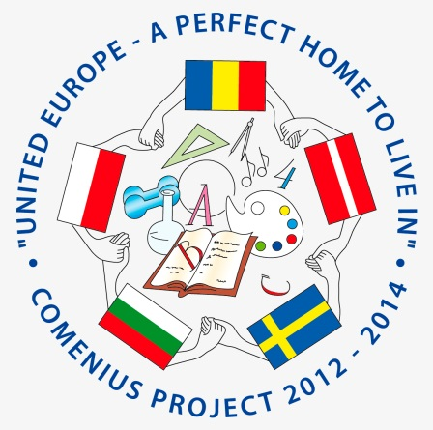
Students’ schedule
LYCKESKOLAN SWEDEN

April 2 Wednesday
Arrivals
Lunch at school
14-15 workshop with Science center at school (Poland and Romania)
Coffee break
15-21 Students welcome to “after school”/fritidsgården with swedish students

April 3 Thursday
9-10 Assembly with local authorities at school
10.00-11.30 Spring show at school/ Welcome show
11.30-12.30 Lunch at school
12.30-13.30 Recycling session
13.30-17 Activity
FREE AFTERNOON/EVENING

April 4 Friday
8.45 Meet at school
9.00 Walk to upper secondary school
9.30-11 Kunskapens hus (upper secondary school)
Tour of school and information about their international work
Walk back to Lyckeskolan
11.30-12.30 Activity at school
12.30 Lunch at school
13.30-16.30 Sports at school
FREE AFTERNOON
PARTY/ACTIVITIES

April 5 Saturday
11.00 leave from school
12.30-14.00 Grimeton Radio station (world heritage site)
Picnic lunch
14-16 Varberg
Fortress+walk along the sea/free time in the city
17.30 Return home
19.30-22.00 Cinema at school

April 6 Sunday
10.00 leave from school
Gothenburg
11.00 Universeum Science center
Picnic lunch
Slottsskogen (Local park)/ visit the museum of natural history (depending on weather)
Shopping/Free time in the city
19.00 Return home

April 7 Monday
9-12 Visit regular lessons with your host
12.00-13 Lunch at school
13.30-15.00 Mariebergsparken –local park, BBQ and games
18.30 Farewell Dinner at school- students+teachers
15-21 Students welcome to “after school”/fritidsgården with hosts if they want

April 8 Tuesday
Impressions
Departures

WELCOME!!

