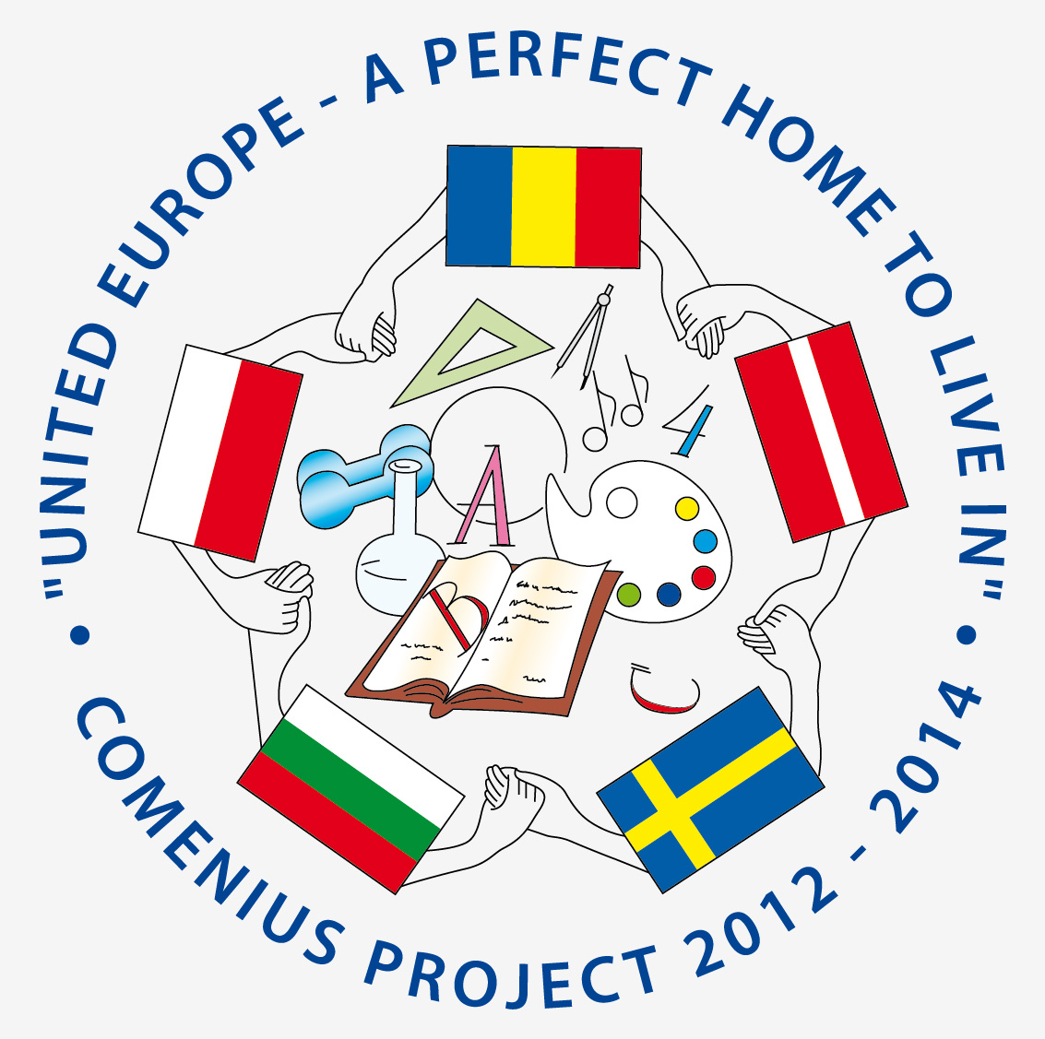
UNITED EUROPE - A PERFECT HOME TO LIVE IN
COMENIUS PROJECT 2012 - 2014
PROJECT MEETING SCHEDULE
SLIVEN, BULGARIA
17.04.2013 - 23.04.2013
FOR TEACHERS
17.04.2013
- ARRIVAL DAY
- ACCOMODATION TO THE HOTEL”KREDO”
- EVENING FREE
18.04.2013
- 8.00 - BREAKFAST
- 9.30 - WELCOME CEREMONY.
- 9.45 - 11.00 – PERFORMANCE OF BULGARIAN SPRING CUSTOMS BY STUDENTS. DISPLAYING PRESENTATIONS ABOUT BULGARIA, SLIVEN AND THE SCHOOL
- 11.00 - 12.30 – VISIT TO THE ART GALLERIES “SIRAK SKITNIK” / ORPHAN WANDERER / AND “DIMITAR DOBROVICH”
- 12.30 - 13.30 –LUNCH
- 13.30 – 14.30 – REGIONAL INSPECTORATE OF EDUCATION, SLIVEN
- 14.30 - 15.30 – VISIT THE HISTORICAL MUSEUM
- 15.30 - 17.30 – BULGARIAN STUDENTS TELL ABOUT SIGHTSEEINGS OF SLIVEN.
- 18.00 – 19.00 WORK MEETING
- 19.00-20.00 DINNER
19.04.2013
- 8.00-8.30 – BREAKFAST
- 9.00-10.00 – ACTIVITIES AT SCHOOL
- 10.00 - 11.00 - MEETING WITH THE MAYOR OF SLIVEN
- 11.00 - 12.30 – WORK MEETING: EDUCATIONAL SYSTEMS IN THE PROJECT COUNTRIES – PRESENTATION
- 12.30 - 13.30 – LUNCH AT HOTEL KREDO
- 14.00-15.30- VISIT TO III PRIMARY SCHOOL
- 15.30- 17.00 – WORK MEETING: WORK MEETING: EDUCATIONAL SYSTEMS IN THE PROJECT COUNTRIES – DISCUSSIONS
- 17.00- 18.00 – TOUR OF THE SCHOOL
- 18.00 – 19.00 DINNER

20.04.2013
- TRIPS IN THE MOUNTAIN “KARANDILA” - Natural Park
" Blue Stones"
- PICNIC
- SPORT ACTIVITIES
21.04.2013
- TRIP TO NESSEBAR, SUNNY BEACH AND BURGAS
- SIGHT – SEEINGS
- WORK MEETING

22.04.2013
- 8.00 – BREAKFAST
- 9.00 - 10.30 VISIT TO THE Museum of textile industry
- 10.30 - 12.00 - EVALUATION OF THE MEETING
- 12.30 - 13.30 - LUNCH AT HOTEL KREDO
- 13.30 - 14.30 - VISIT TO THE MUSEUM OF EDUCATION IN SCIENSE MATHEMATIC SCHOOL
- 15.00 - 16.30 – WORK MEETING
- 17. 00 – 18.30 - RELAXING, FREE TIME
- 18.30 - 22.00 - FARE WELL DINNER
23.04.2013
- SAYING GOODBYE, KISSES AND HUGS
- DEPARTURE DAY
- WAY TO SOFIA AIRPORT

