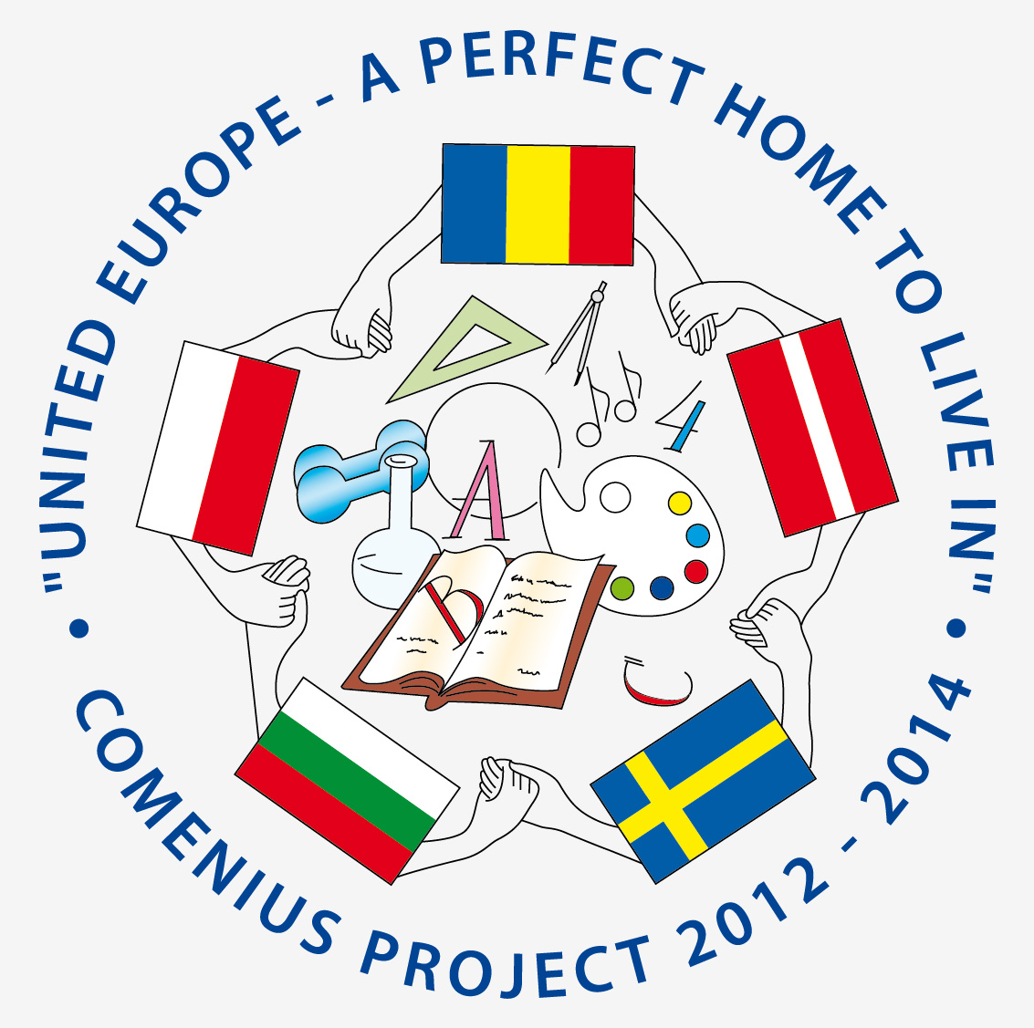



COMENIUS PROJECT “UNITED EUROPE - A PERFECT HOME TO LIVE IN”
2012 - 2014
MEETING SCHEDULE
SLIVEN, BULGARIA
27.02.2014 - 03.03.2014

27.02.2014 THURSDAY
- ARRIVAL DAY
- ACCOMODATION TO THE HOTEL ”NATIONAL PALACE”
- EVENING FREE

28.022014 FRIDAY
- 08.00 - 08.30 BREAKFAST
- 09.00 - 09.30 WELCOME CEREMONY.
- 09.30 - 10.00 LESSON IN ROAD SAFETY
- 10.00 - 10.40 DEMONSTRATION OF SAFE DRIVING
- 10.45 - 11.15 ENGLISH LESSON
- 11.30 - 12.15 VISIT TO SCHOOL FOR CHILDREN WITH SPECIAL EDUCATIONAL NEEDS
„VLASAKI SHUMANOV”
- 12.30 -13.30 LUNCH AT SCHOOL
- 14.00 -15.00 OFFICIAL OPENING OF THE NEWLY EQUIPPED AND MODERNIZED WORKSHOPS OF THE
SCHOOL BY THE WINNING PROJECT. GUESTS OF THE EVENT WILL BE THE GOVERNOR OF
THE CITY OF SLIVEN, THE CITY MAYOR, THE HEAD OF THE INSPECTORATE ON EDUCATION,
INSPEKTORATA REPRESENTATIVES, EMPLOYERS.
- 15.30 - 17.30 WORK MEETING
- 17.30 - 19.00 FREE TIME
- 19.00 – 20.00 DINNER AT HOTEL ”NATIONAL PALACE”

01.03.2014 SATURDAY
- 08.00 – 9.00 BREAKFAST
- 9..11.00- WORK MEETING
- 11.00 EXCURSION TO THE TOWN OF KOTEL AND THE VILLAGE OF JERAVNA –
MONUMENTS OF CULTURE AND ARCHITECTURAL RESERVES
- VISIT TO THE GALATA SCHOOL IN KOTEL – EXEBITION OF HANDMADE CARPETS
AND TRADITIONAL MUSIC PESENTED BY TEACHERS FROM THE MUSICAL SCHOOL
- LUNCH AT ZARKA’S HOUSE IN ZHERAVNA
- GOING TO THE CHURCH ‘’SAINT NICOLAS’’
- SIGHTSEEING
- 17.00-18.30 – WORK MEETING
- 19.00 – 20.00 - DINNER

02.03.2014 SUNDAY

- 08.00 – 09.00 BREAKFAST
- 09.00 -11.00 –WORK MEETING
- 11.00 –16.30 - DEPARTURE FROM SLIVEN. :EXCURSION TO THE TOWN OF KAZANLAK - THE VALLEY OF
- ROSES AND THRACIAN KINGS , VISIT TO Thracian tomb "Big Hairy" , VISIT TO THE
- MUSEUM OF BULGARIAN ROSE TOGETHER WITH THE TEACHERS FROM THE SCHOOL
- ACCOMMODATION IN THE HOTEL "Chiflika" in the town OF KAZANLAK
- VISIT TO Kazanlak tomb
- 17.00-18.30 – WORK MEETING
- 19.30-21.30 - GALA DINNER

03.03.2014

- 08.00-09.00 – BREAKFAST
- 09.00-10.30- EVALUATION
- SAYING GOODBYE, KISSES AND HUGS
- DEPARTURE DAY / FROM KAZANLAK /
- TRAVEL TO SOFIA AIRPORT

