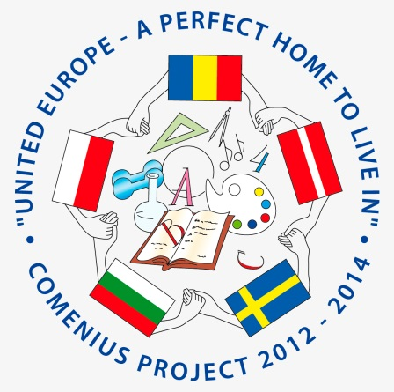
Teachers’ schedule
LYCKESKOLAN SWEDEN
April 2 Wednesday
Arrivals
Lunch at school
14-15 work shop with Science center at school (Poland and Romania)
Coffe break
Meet host families
20.00 Dinner at hotel

April 3 Thursday
9.00-10.00 Assembly and coffee with local authorities at school
10.00-11.30 Spring show at school/ Welcome show
11.30-12.30 Lunch at school
12.30-13.30 Recycling session
13.30-15 Meeting (Coffee while working)
FREE AFTERNOON
19.00 Dinner at hotel
April 4 Friday
8.45 Meet at school
9.00 Walk to upper secondary school
9.30-11.00 Kunskapens hus (upper secondary school) BRING GIFT
Tour of school and information about their international work
11.30-12.30 Activity at school
12.30 Lunch at school
13.20-15.20 MEETING- teachers (Coffee while working)
19.00 Party for teachers

April 5 Saturday
11.00 leave from school
12.30-14.00 Grimeton Radio station (world heritage site)
Picnic lunch
14-16 Varberg
Fortress/walk along the sea/free time in the city
17.30 Return home
19.30 Dinner at Malin’s house

April 6 Sunday
10.00 Leave school
Gothenburg
11.00 Universeum Science center
Picnic lunch
Slottsskogen (Local park)/ visit the museum of natural history (depending on weather)
Shopping/Free time in the city
19.00 Return home
20.00 Dinner

April 7 Monday
9-11 Visit regular Lessons
11-12 Meeting (evaluation)
12-13 Lunch at school
13.20-15.20 Mariebergsparken –local park, BBQ and games
18.30 Farewell Dinner at school- students+teachers

April 8 Tuesday
Departures

Some changes to the schedule may apply- hopefully minor! ☺
WELCOME!!

